# **PROJECT REPORT**

Presented to Faculty of



**P. E. Society’s**

**Modern College of Arts, Science & Commerce (Autonomous)**

**Shivajinagar, Pune – 411005**

**Department of Computer Science**

**M.Sc. Computer Application-II, Semester-IV**

**2021-22**

In Partial Fulfillment of the Requirement Semester IV Industrial Training

## At

Bluepineapple

(Nebbia Technology) By

**Akshay Suresh Vishwakarma**

Seat No- 2000026, Semester IV (2021-2022) MASTERS OF COMPUTER APPLICATION (MSC. CA)

Under The Guidance of

**College Mentor Industrial Mentor**

**1. Prof. S.S Deshmukh 1. Jay Seth**

**2. Suresh Burde**

**3. Avinash Thathe**

## C E R T I F I C A T E

This is to certify that Mr. /Ms. **Akshay Suresh Vishwakarma**

(Exam. Seat No. **2000026** ) is a student of M. Sc. CA (Computer Applications), Part II, Semester IV, and undergoing Industrial Training at

**BLUEPINEAPPLE (Nebbia Technologies India Private Limited)**

1. Internal Guide _
2. Internal Examiner
3. External Examiner
4. Industry Expert



**P. E. Society’s**

**Modern College of Arts, Science & Commerce (Autonomous)**

**Shivajinagar, Pune – 411005**

**Department of Computer Science**

**M.Sc. Computer Application-II, Semester-IV**

**2021-22**

## ACCEPTANCE

This is to certify that the undersigned have assessed and evaluated the Project “Sports Live” submitted by **Akshay Suresh Vishwakarma**. The project report has been accepted for the Partial fulfillment of the degree of M.Sc. Computer Application from Modern College, Pune.

1. Internal Guide
2. Internal Examiner __________________________________________
3. External Examiner __________________________________________
4. Industry Expert

PLACE: PUNE DATE:

## Acknowledgments

I would like to express my gratitude towards my parents, my college guides and all the team members of Bluepineapple for their kind co-operation and encouragement which helped me in completion of this internship project. I am highly in credited to Bluepineapple Organization for their guidance and constant supervision as well as for providing necessary information regarding the project & also for their support in completing the same. I would like to show my greatest appreciation to Mr. Suresh Burde (Principal Architect at Bluepineapple) for his immense support, encouragement & belief on the team. My thanks and appreciations also go to my colleagues in developing the project and people who have willingly helped me out with their abilities. I would like to extend my sincere thanks to all of them.

## DECLARATION

I, **Akshay Suresh Vishwakarma** hereby declare, that the project report entitled “Sports Live” is completed and written by me as a part of the team allotted to me at Bluepineapple and has not previously formed the basis for the award of any degree or diploma or other similar title of this or any other university or examining body.

PLACE: PUNE

DATE:

## TABLE OF CONTENTS

Introduction 11

About the project 11

Application Features 12

Assumptions 12

Out-of-scope 12

Caveats… 12

Feasibility study 12

Technical feasibility 12

Market research and analysis 12

Unique preposition & value creation 13

Stakeholder Analysis 13

Identification of stakeholders 13

Persona identification 14

Stakeholder engagement 15

Stakeholder communication 15

Project Plan 16

Project Management Plan 16

Project Scope 17

Project Team structure, roles and responsibilities 17

Project Tracking, Scheduling 18

Product Backlog, Scrum cycle, methodology 19

Requirement Analysis 20

Requirement collection methods used 20

User Stories 21

Detailed User Stories Description 22

Requirements Estimation 34

Effort Estimation Report 37

Design 39

Peer Review Process 39

Collaboration Methodology 39

Coding Guidelines 40

Source Code Repository 41

Technical stack details 41

Technologies used, their versions 41

Database Design 43

Class Diagram 43

Sequence diagram 44

Use Case Diagram 45

Wireframes 46

Development 69

Application Features 69

Testing …………………………….……70

Implementation 77

Conclusion 104

References 106

**Glossary …………………………………****106**

## LIST OF TABLES

## Table 1.0 List of All Must Have User Stories ………………..…………………………………………………………..................22

## Table 1.1.1 Landing Page Integration ………………..…………………..………………………………………………..................23

## Table 1.1.2 Cricket Featured Match Page Integration………………..…………………………..………..……...................23

## Table 1.1.3 Cricket Teams Page Integration …………………………..………………………………………………..................24

## Table 1.1.4 Cricket Schedule Match Page Integration ………………..……………….…………………………..................24

## Table 1.1.5 Cricket Players Page Integration ………………..…………………..…………………….....…………..................25

## Table 1.1.6 Cricket Statistic Page Integration ………………..………………………………………………………..................26

## Table 1.1.7 Cricket News Page Integration ………………..………………….………………………………………..................26

## Table 1.1.8 Cricket Ranking Page Integration ………………..…………………..…….……………………………..................27

## Table 1.1.9 Cricket Live Score Page Integration ………………..……………………………………………………..................27

## Table 1.1.10 Cricket Series Page Integration ………………..…………..……………………………………………..................28

## Table 1.1.11 Cricket Search Part Integration ………………..…………..……………………..……………………..................29

## Table 1.1.12 Football Live Score Page Integration ………………..……………….………………………………..................30

## Table 1.1.13 Football League Match Page Integration ………………..…………………..……….……………..................30

## Table 1.1.14 Detailed League Page Integration ………………..…………………..…….…………………………..................31

## Table 1.1.15 Football News Page Integration ………………..………………………………………………………..................33

## Table 1.1.16 FIFA Ranking Page Integration ………………..…………………..……………………………………..................33

## Table 1.1.17 Football Gallery Page Integration ………………..…………………..…………….…………………..................34

**Table 1.2.1 Development Estimation…………………………………….………………………………………………..................35**

#### Table 1.2.2 Estimating Document Estimation…………………………………………………………………………..................35

## Table 1.2.3 Design Estimation ………………..…………………..……………………………………..…………………..................36

## Table 1.2.4 Planning Estimation ………………..…………………..…………………..…………………………………..................36

## Table 1.2.5 Study & Setup Estimation ………………..…………….…..………………………………………………..................37

## Table 1.2.6 Documentation Estimation ………………..…………….…..……………………………………………..................37

## Table 1.3 Comparison Report of All SDLC Phase Estimation ………………..…………….….………………..................38 Table 1.4 Total Estimation Report ………………..…………………..…..………………………………………………..................39 Table 1.5 Summary of Estimation ………………..…………….…..……………………………………………….……..................39 Table 1.6.1 Server-Side libraries…………………………………………….………………………………………………..................42

## Table 1.6.2 Client-Side libraries ………………………………….…………………………………………………………..................43

## Table 1.7 Application Features ………………………………….…………………….……………………………………..................71

## Table 1.8.1 Cricket Home Page – Search Bar ……………….…………………………………………………………..................72

## Table 1.8.2 Cricket Home Page – Team Nav-Item ………………………………….………………………………..................73

## Table 1.8.3 Home Page – Live Score Nav-Item ………………………………….……………………………………..................73 Table 1.8.4 Home Page – News Nav-Item ………………………………….……….…………………………………..................73 Table 1.8.5 Cricket Home Page – Ranking Nav-Item ……………………………..………………………………..................74

## Table 1.8.6 Cricket Home Page – Series …………………………………………………………………………………..................74

## Table 1.8.7 Football League Page – League ……………………………………………………………………………..................74

## Table 1.8.8 Football Ranking Page – Ranking ………………………………….……………………………….……..................75

## Total 1.9.1 Team Data…………….………………………………….…………………………………………………………..................75 Table 1.9.2 News Data ………………………………….………………………………………………………………………..................76 Table 1.9.3 Player Data. ……………………………….…………….…………………………………………………………..................76 Table 1.9.4 Series Data ……………………………………………….…………………………………………………………..................77 Table 1.9.5 League Data ……………………….…………………….…………………………………………………………..................77 Table 1.9.6 Ranking Data ……………………..…………………….…………………………………………………………..................7

## LIST OF FIGURES

## Figure 1.0 Gantt Chart ……………………………………….……….…………………………………………………………..................19

## Figure 1.1 Class Diagram…………………………………….……….…………………………………………………………..................44

## Figure 1.2 Sequence Diagram ………………………………………..………………………………………………………..................45 Figure 1.3 Use case Diagram………………………..…….……….…………………………………………………………..................46

## Figure 1.4.1 Home Screen ……………………………………….….…………………………………………………………..................47

## Figure 1.4.2 Cricket Home page screen……………….……….…………………………………………………………..................48

## Figure 1.4.3 Screen for cricket Live score…………………….…………………………………………………………..................49

## Figure 1.4.4 Screen for Cricket Schedule……………….…….…………………………………………………………..................50

## Figure 1.4.5 Screen for Cricket Series…………………………..…………………………………………………………..................51

## Figure 1.4.6 Screen for Cricket Gallery………………….……….………….……………………………………………..................52

## Figure 1.4.7 Screen to Cricket News………..………….……….…………………………………………………………..................53

**Figure 1.4.8 Screen for Cricket Teams……………………………………………………..………………………………..................54 Figure 1.4.9 Screen for Cricket Teams Schedule.………….………………..……………………..…………………..................55 Figure 1.4.10 Screen for Cricket Teams Players.………….…………..……………………………..………………..................56 Figure 1.4.11 Screen for Cricket Teams Stats…...………….…………..……………………………..………………..................57 Figure 1.4.12 Screen for Cricket Teams Player Info...….…….……..……………………………..………………..................58 Figure 1.4.13 Screen for Football Landing Page………………………..……………………………..………………..................59 Figure 1.4.14 Screen for Football Live Scores …...………..…………..……………………………..………………..................60 Figure 1.4.15 Screen for Football Match Summary…………………..……………………………..………………..................61 Figure 1.4.16 Screen for Football Rankings…………………….………..……………………………..………………..................63 Figure 1.4.17 Screen for Football Leagues …………..…………………..……………………………..………………..................64 Figure 1.4.18 Screen for Football League Schedule.………….……..……………………………..………………..................65 Figure 1.4.19 Screen for Football League Teams…….………………..……………………………..………………..................66 Figure 1.4.20 Screen for Football League points Table……………..……………………………..………………..................67 Figure 1.4.21 Screen for Football Team Details………………………..……………………………..………………..................68 Figure 1.4.22 Screen for Football Gallery………………………….……..……………………………..………………..................69 Figure 1.4.23 Screen for Football News……………………………….…..……………………………..………………..................70**

Introduction

### About the project

Last decade has been one, to remember in terms of sports in India, our country has achieved a lot of milestones and we have done better in those sports which were considered out of reach for Indians. These huge achievements in the sports have created a lot of fan base, especially to the young generation, who not only love to play or watch these sports but are also eager to know every bit of it. To get such updates we have some apps like Cricbuzz. But as we know India is a country where cricket is treated as a religion, this app only focuses on cricket, but what about those people who love to play or watch other sports, sadly for these people there are very limited or no platforms where they can get updates about their favorite game, and the available apps focuses on only some popular sports. Hence, to overcome this limitation the current system has been developed which provides live updates of multiples sports (both football and cricket as of now) along with information regarding the stats, scorecard, rankings and some statistical data in graphical form.

#### Application Features:

The website will cover below sports:

* Cricket
* Football

Under each category it will have

* Ongoing matches
* Upcoming matches
* Scorecard
* Players, teams and match statistics
* News

#### Assumptions

* The data received from the API is true and correct.
* Sports for which the system has been built is Cricket & Football considering it to be the popular ones among majority of people.
* This application will be used for entertainment / informative use only.

#### Out-of-scope

* More sports can be added in the future.
* The data received from the API is limited due to which all information may not be available currently in the system.
* No premium membership / subscription added yet.

#### Caveats:

* Our application is partially dependent on third party API .If sometimes they won't work properly then the application will have an issue.

### Feasibility study

#### Technical feasibility

Open source and reliable software-frameworks will be used, hence it is technically feasible

* NodeJS with Express for back-end server.
* ReactJS for front-end.
* MongoDB for Database Management.

#### Market research and analysis

Sports Live is a platform that features news, articles, and live coverage of matches, player’s information, and team rankings etc.

Talking about the market size of the sports industry across India, it was over 18 billion Indian rupees in 2021. Most of the media consumption in the sports industry in the country was from the Indian Premier League. Recently however, other domestic leagues like Pro Kabaddi and the Indian Super League have gained popularity.

There is one interesting fact that the Indian sports market size keeps growing each year, and it is estimated to be worth $27.89 billion dollar in 2022. This means that people have been and will always be interested in sports. Therefore, the business owners operating in the sports industry should expect high profits, given a proper business strategy, planning, and management.

So, why not to enter the market using one of the most innovative approaches, developing a custom web app and launching it for the mass market.

#### Unique preposition & value creation

This system proposes a single app which will incorporate multiple sport events and news so that users don’t have to search or browse at multiple locations. It also presents statistical data graphically, to visually illustrate the data.

### Stakeholder Analysis

#### Identification of stakeholders

Internal stakeholders -

* Employees
* Managers External stakeholders -
* API provider
* Users / Customers

#### Persona identification

**Persona 1** Name - Alan Age - 20

Psyche - Introvert Background - CSE student

Emotions towards tech - Likes technology and detailed info of an event

Needs of this persona and situations - Alan is a computer student and likes sports very much. He likes to check his favorite team’s schedule and scores and compare their performance with previous matches and other teams. He likes to be updated with the live score of an event when he’s busy doing other work.

**Persona 2** Name - Rick Age - 35

Psyche - Extrovert Background - Sales manager

Emotions towards tech - Experienced with technology and likes basic information of an event. Needs of this persona and situations - Rick is a sales manager at a company. He works hard at his job and enjoys sports in his leisure time. He enjoys multiple sports and likes to be updated with the latest news and matches. Rick doesn't have much time and patience to look through a lot of pages and likes information in a compact manner.

#### Stakeholder engagement

Engage the internal stakeholders, plan an action and act.

#### Stakeholder communication

Communicate with internal stakeholders daily via scrum calls and internal meetings.

# Project Plan

### Project Management Plan

#### Objectives:

* Build a well-designed working back-end.
* Build an attractive and user-friendly UI.
* Deploy the project.
* Market and advertise the site.

#### Time frame:

* Phase 1: Project design
* Phase 2: Prototyping
* Phase 3: Deliverable 1
* Phase 4: Testing & Deployment

### Project Scope

The idea of sports lives is to provide real time information about sports results from various disciplines. There are now few websites providing live sports. With sports live it is possible to follow live results of many events at the same time, our application also provides some additional information, such as a player list, player details, player statistics, upcoming schedules and representation of statistical data graphically etc. where fans of different sports can gather and can get all possible information about their favorite sports and sports person.

### Project Team structure, roles and responsibilities

Atharva M - Full stack developer Akshay V - Full stack developer Mokshada M - Full stack developer

#### Responsibilities:

Atharva M – Designing and Implementation Akshay V – Designing and Implementation Mokshada M – Designing and Implementation

### Figure 1.0 Project Tracking, Scheduling

A Gantt chart is used to track all the tasks which are scheduled. The project schedule contains:

* A project timeline with start dates, end dates and milestones
* The work necessary to complete the project deliverables
* The team members that are responsible for each task

### Product Backlog, Scrum cycle, methodology

#### Product Backlog

Trello is being used for keeping track of product backlogs and agile sprints. The Trello board used has a list for:

* Product backlogs
* To Do
* Doing
* QA
* Done

#### Scrum Cycle

Considering the time frame for the project, we have a week sprint duration. In this cycle, the team decides on a goal for that week, and conducts a daily scrum call at the start of the day to discuss what tasks each team member will do for that respective day.

After which, at the end of every sprint, review of the work with the previously set goal and assessing the speed and performance of the team is done along with look for ways to improve it.

### Requirement Analysis

As the goal of the application is ease of use and to provide an interactive interface, research has been done to gain an insight into the needs and behaviors of various users. The working of the application is made convenient and easy to use for the end user.

#### Requirement collection methods used

To produce the Organization, Vision and Scope of the application, a method is proposed consisting of a series of activities that is ordered in a certain way. In these methods, there are activities for resolving the sports-live key elements to ensure that the developed sports-live website/application will lead to business success. The rationales of the proposed method are as follows:

###### Questionnaire

Some basic questions were prepared based on the analysis done with close circles (friends and family) to identify what people want to see in sports related applications.

###### Analyzing similar websites:

The purpose of these activities is to learn/analyze the competitors and the results are then used to formulate the key elements of the competitive environment and advantages. This includes tasks such as analyzing the web features that annoy as well as impress users (page layouts, navigation between pages, ease of use, guidance, etc.)

### User stories

**Table 1.0 List of All Must Have User Stories**

|  |  |
| --- | --- |
| **Sr. No** | **User Stories** |
| 1. | As a user I want to see options of multiple sports. |
| 2. | As a user I want to see Details of Featured Matches of Cricket. |
| 3. | As a user I want to see the Teams of Cricket. |
| 4. | As a user I want to see the Schedule matches of Each Team of Cricket. |
| 5. | As a user I want to see the Players of Each Team of Cricket. |
| 6. | As a user I want to see the Statistic part of Each Team of Cricket. |
| 7. | As a user I want to see the Latest News of Cricket. |
| 8. | As a user I want to see the Rankings of Players according to their Role (Batting, Bowl- ing) as well as type of Matches (Test, ODI, T20) of Cricket. |
| 9. | As a user I want to see the Live Score in sorted format according to Type of Match. |
| 10. | As a user I want to see the List of Series and their Details of Cricket. |
| 11. | As a user I want to Search for a player by their Name and see their Details. |
| 12. | As a user I want to see the Live Score of Football. |
| 13. | As a user I want to see the List of League Matches of Football. |
| 14. | As a user I want to see the Details of the Particular League,   * League matches * Teams * Point Table |
| 15. | As a user I want to see the Latest News of Football. |
| 16. | As a user I want to see the latest FIFA Rankings. |
| 17. | As a user I want to see the Gallery of Football. |

### Detailed User Stories Description

This part of the project describes, detailed description of each user story mentioned above with the tasks listed to complete its development along with the estimated as well as actual time required to achieve it.

**1 unit = 60 mins** on which estimated and actual time is calculated.

**Table 1.1.1 Landing Page Integration**

|  |  |
| --- | --- |
| Sr. No. | 1 |
| User Story | As a user I want to see options of multiple sports. |
| Description | On a Landing Page of our website,  On top navigation Bar We are Showing two main sports categories (Football and Cricket) After Clicking on that it will navigate to the home Page of that sport. |

|  |  |  |  |
| --- | --- | --- | --- |
| Task. No. | Task | Expected Time (units) | Actual Time (units) |
| 1. | Creating UI of Landing Page | 6 | 5 |
| 2. | Backend Integration of Landing Page | 7 | 5 |
| Total |  | 13 | 10 |

**Table 1.1.2 Cricket Featured Match Page Integration**

|  |  |
| --- | --- |
| Sr. No. | 2. |
| User Story | As a user I want to see Details Featured Matches of Cricket. |
| Description | On the Home Page of Cricket at the top of Page we are showing the short Details of Featured matches in card format. After clicking on the card it will navigate to the Detailed page of Featured matches and on that page we are showing the name, date and time, venue, live score of that match. |

|  |  |  |  |
| --- | --- | --- | --- |
| Task No. | Task | Expected Time (units) | Actual Time (units) |
| 1. | Create cards of Featured matches on Home Page with backend integration | 7 | 9 |

|  |  |  |  |
| --- | --- | --- | --- |
| Task No. | Task | Expected Time (units) | Actual Time (units) |
| 2. | Create Detailed Page for Featured matches by showing all the data fields. | 7 | 9 |
| 3. | Create endpoints of matches and Backend integration of Detailed Page. | 8 | 9 |
| Total |  | 22 | 27 |

**Table 1.1.3 Cricket Teams Page Integration**

|  |  |
| --- | --- |
| Sr. No | 3. |
| User Story | As a user I want to see the Teams of Cricket. |
| Description | On the Home Page of Cricket at the top of Page there is a navbar on which we have Teams nav. After clicking on Teams it will navigate to the team page on that page we are showing flag and name of teams in table format. |

|  |  |  |  |
| --- | --- | --- | --- |
| Task No. | Task | Expected Time (units) | Actual Time (units) |
| 1 | Creating navbar, adding nav items and routing work. | 1 | 1 |
| 2. | Creating UI of Team page, Create end- point of teams and backend integration. | 10 | 13 |
| Total |  | 11 | 14 |

**Table 1.1.4 Cricket Schedule Match Page Integration**

|  |  |
| --- | --- |
| Sr. No | 4. |
| User Story | As a user I want to see the Schedule matches of Each Team of Cricket. |
| Description | On the Team page there is a list of teams in tabular format after clicking on a particular team it will navigate to the Team Detail page on that page there is a schedule button on click on that List of all schedule matches is displayed in list format. |

|  |  |  |  |
| --- | --- | --- | --- |
| Task No. | Task | Expected Time (units) | Actual Time (units) |
| 1 | Make each team card clickable and han- dle routing so after clicking it will go to Team Details Page. | 2 | 4 |
| 2. | Create Team Detail Page with Schedule button and create UI of schedule compo- nent. | 8 | 11 |
| 3. | Create endpoints of schedule matches and backend integration of team Detail page and schedule page. | 10 | 10 |
| Total |  | 20 | 25 |

**Table 1.1.5 Cricket Players Page Integration**

|  |  |
| --- | --- |
| Sr. No | 5. |
| User Story | As a user I want to see the Players of Each Team of Cricket. |
| Description | On the Team page there is a list of teams in tabular format after clicking on a particular team it will navigate to the Team Detail page on that page there is a Players button on click on that List of all Players is displayed in list format who are under that team. |

|  |  |  |  |
| --- | --- | --- | --- |
| Task No. | Task | Expected Time (units) | Actual Time (units) |
| 1 | Create Team Detail Page with Player but- ton and Create UI of player component. | 8 | 10 |
| 2. | Create endpoints of players of a  particu lar team with backend integration. | 10 | 11 |
| Total |  | 18 | 21 |

**Table 1.1.6 Cricket tem statistics integration page**

|  |  |  |  |
| --- | --- | --- | --- |
| Task No. | Task | Expected Time (units) | Actual Time (units) |
| 1. | Create Team Detail Page with Statistic but- ton and Create UI of statistic component | 8 | 10 |
| 2. | Create endpoints of statistics of that team and backend integration of team Details and statistic page | 10 | 11 |
| Total |  | 18 | 21 |

**Table 1.1.7 Cricket News Page Integration**

|  |  |
| --- | --- |
| Sr. No. | 7. |
| User Story | As a user I want to see the Latest News of Cricket. |
| Description | On the Home Page of Cricket at the top of Page there is a navbar on which News nav-item is there. After clicking on that cricket related News will be dis- played on News page. |

|  |  |  |  |
| --- | --- | --- | --- |
| Task No. | Task | Expected Time (units) | Actual Time (units) |
| 1. | Updating navbar, adding News nav-item and routing work. | 1 | 1 |
| 2. | Creating UI of News page, Create endpoint of News and backend integration | 8 | 9 |
| Total |  | 9 | 10 |

**Table 1.1.8 Cricket Ranking Page Integration**

|  |  |
| --- | --- |
| Sr. No. | 8. |
| User Story | As a user I want to see the Rankings of Players according to their Role (Bat- ting, Bowling) as well as type of Matches (Test, ODI, T20) of Cricket. |
| Description | On the Home Page of Cricket at the top of Page there is a navbar having Rank- ing nav-item. After clicking on that, Ranking Page will be displayed that  Page contains Batting and Bowling navbar at the top and below that user has options of Test, ODI, and T20. So when user clicks according to his/her choice rankings of the player according to the format will be displayed. |

|  |  |  |  |
| --- | --- | --- | --- |
| Task No. | Task | Expected Time (units) | Actual Time (units) |
| 1. | Updating navbar, adding ranking nav-item and routing work | 1 | 1 |
| 2. | Creating UI of ranking page, create end- point of ranking (batting, bowling, test, ODI, T20) and their backend integration | 16 | 18 |
| Total |  | 17 | 19 |

**Table 1.1.9 Cricket Live Score Page Integration**

|  |  |
| --- | --- |
| Sr. No. | 9. |
| User Story | As a user I want to see the Live Score in sorted format according to type of Match. |
| Description | On the Home Page of Cricket at the top of Page there is a navbar having  Live scores nav-item. After clicking on that it will navigate to the score page on top of the page there is one dropdown on which user can select match type and then we are displaying match list in sorted format according to match type and in that card it will show you the match details :   * Team Names * Date and time * Venue * Live score * Status and match type |

|  |  |  |  |
| --- | --- | --- | --- |
| Task No. | Task | Expected Time (units) | Actual Time (units) |
| 1. | Updating navbar, adding Live Score nav- item and routing work | 1 | 1 |
| 2. | Creating UI of Score page | 8 | 8 |
| 3. | Create endpoint of matches and their backend integration | 5 | 5 |
| Total |  | 14 | 14 |

**Table 1.1.10 Cricket Series Page Integration**

|  |  |
| --- | --- |
| Sr. No. | 10. |
| User Story | As a user I want to see the list of series and their details. |
| Description | On the Home Page of Cricket at the top of page there is a navbar on which Series nav-item is there. Clicking on that will navigate to the series page on that we are showing list of series and other details of each series like:   * Name of Series * Start Date * End Date * TEST, ODI, T20 Matches * Total Matches |

|  |  |  |  |
| --- | --- | --- | --- |
| Task No. | Task | Expected Time (units) | Actual Time (units) |
| 1. | Updating navbar, adding series nav-item and routing work | 1 | 1 |
| 2. | Creating UI for series page | 5 | 8 |
| 3. | Create endpoints for series and its backend integration | 6 | 8 |
| Total |  | 12 | 17 |

|  |  |
| --- | --- |
| Sr. No. | 11. |
| User Story | As a user I want to search for player by player name and see the details of that player. |
| Description | On the Home Page of cricket at the top of page there is a navbar which have search option where user can search by player name and then list of players will be appear and after clicking on player name it will navigate to player info page on that page we are showing :   * Personal Information * Debut * Batting career summary * Bowling career summary |

|  |  |  |  |
| --- | --- | --- | --- |
| Task No. | Task | Expected Time (units) | Actual Time (units) |
| 1. | Updating navbar, adding search textbox. | 1 | 1 |
| 2. | Create UI of player info page. | 6 | 8 |
| 3. | Create endpoint of player details and backend integration of search task and player Info page. | 8 | 10 |
| Total |  | 15 | 19 |

**Table 1.1.11 Cricket Search Part Integration**

**Table 1.1.12 Football Live Score Page Integration**

|  |  |
| --- | --- |
| Sr. No. | 12. |
| User Story | As a user I want to see the live Score of football. |
| Description | On the home page of football at the top of page there is a navbar on which there is a live score nav-item. After clicking on that it will navigate to the score page on top of the page there is one dropdown on which user can select league and then we are displaying match list in sorted format according to league name and in that card it will show you the match details :   * Team names * Date * Series * Live score * League season and status |

|  |  |  |  |
| --- | --- | --- | --- |
| Task No. | Task | Expected Time (units) | Actual Time (units) |
| 1. | Create navbar and adding live score nav- item and routing work. | 1 | 1 |
| 2. | Create UI of score page with all data fields. | 6 | 7 |
| 3. | Create endpoints of live score and backend integration of score page. | 6 | 7 |
| Total |  | 13 | 15 |

**Table 1.1.13 Football League Match Page Integration**

|  |  |
| --- | --- |
| Sr. No. | 13. |
| User Story | As a user I want to see the list of league matches of football. |
| Description | On the home page of football at the top of page there is a navbar league after clicking on league it will navigate to the league page on that page we are showing:   * League Country * Country Name * League Logo * League Name |

|  |  |  |  |
| --- | --- | --- | --- |
| Task No. | Task | Expected Time (units) | Actual Time (units) |
| 1. | Create navbar and adding League nav-item and routing work | 1 | 1 |
| 2. | Create UI of league page with all data fields. | 5 | 6 |
| 3. | Create endpoints of league and backend integration of league page. | 6 | 6 |
| Total |  | 12 | 13 |

**Table 1.1.14 Detailed League Page Integration**

|  |  |
| --- | --- |
| Sr. No. | 14. |
| User Story | As a user I want to see the details of the particular league :   * League matches * Teams * Point Table |
| Description | On league page there is a list of league in tabular format after clicking on a particular league it will navigate to the league detail page on that page there is a league matches button on click on that we showing list of matches under that league and beside that there is teams button on click of that we are showing list of teams beside that there is a point table but- ton on click on that we are showing points table details in tabular format. |

|  |  |  |  |
| --- | --- | --- | --- |
| Task No. | Task | Expected Time (units) | Actual Time (units) |
| 1. | Make each league card clickable and han- dle routing so after clicking it will go to league detail page. | 2 | 3 |
| 2. | Create league detail page with league matches button and create UI of league matches component | 7 | 8 |
| 3. | Create endpoints of league matches and backend integration of league detail page and league matches page. | 7 | 7 |
| 4. | Update league detail page with teams but- ton and create UI of team’s component. | 6 | 6 |
| 5. | Create endpoints of teams and backend integration of league detail page and team’s page. | 7 | 7 |
| 6. | Update league detail page with point table button and create UI of point table component. | 6 | 5 |
| 7. | Create endpoints of point’s table and backend integration of league detail page and point’s table page. | 7 | 6 |
| Total |  | 42 | 43 |

**Table 1.1.15 Football News Page Integration**

|  |  |
| --- | --- |
| Sr. No. | 15. |
| User Story | As a user I want to see the latest news of football. |
| Description | After clicking on news on the football nav-bar, football related news will be displayed. |

|  |  |  |  |
| --- | --- | --- | --- |
| Task No. | Task | Expected Time (units) | Actual Time (units) |
| 1. | Updating navbar, adding news nav-item and routing work. | 1 | 1 |
| 2. | Creating UI of news page, create endpoints of news and backend integration | 7 | 6 |
| Total |  | 8 | 7 |

**Table 1.1.16 FIFA Ranking Page Integration**

|  |  |
| --- | --- |
| Sr. No. | 16. |
| User Story | As a user I want to see the latest FIFA rankings. |
| Description | After clicking on rankings on football nav-bar, ranking of teams will be displayed in tabular format.   * Position * Team flag * Team name |

|  |  |  |  |
| --- | --- | --- | --- |
| Task No. | Task | Expected Time (units) | Actual Time (units) |
| 1. | Updating navbar, adding ranking nav-item and routing work. | 1 | 1 |
| 2. | Creating UI of ranking page, create end- point of ranking and backend integration. | 7 | 7 |
| Total |  | 8 | 8 |

**Table 1.1.17 Football Gallery Page Integration**

|  |  |
| --- | --- |
| Sr. No | 17. |
| User Story | As a user I want to see the Gallery of Football. |
| Description | After clicking on gallery on football nav-bar, images and related to football will be displayed. |

|  |  |  |  |
| --- | --- | --- | --- |
| Task No. | Task | Expected Time (units) | Actual Time (units) |
| 1. | Updating navbar, adding gallery nav-item and routing work. | 1 | 1 |
| 2. | Creating UI of gallery page, create end- point of gallery and backend integration | 4 | 3 |
| Total |  | 5 | 4 |

### Requirement Estimation

#### Table 1.2.1 Development Estimation

|  |  |  |
| --- | --- | --- |
| Sr. No | Total Of All Must Have User Stories | Time (units) |
| 1. | Expected Time | 257 |
| 2. | Actual Time | 287 |

#### Table 1.2.2 Estimating Document Estimation

|  |  |  |  |
| --- | --- | --- | --- |
| Task No. | Task (Must Have) | Expected  Time (units) | Actual Time  (units) |
| 1. | Write down User stories. | 12 | 10 |
| 2. | Description of each story. | 20 | 24 |
| 3. | Detailed task analysis. | 20 | 20 |
| 4. | Peer Review. | 24 | 24 |
| TOTAL |  | 76 | 78 |

#### Table 1.2.3 Design Estimation

|  |  |  |  |
| --- | --- | --- | --- |
| Task No. | Task | Expected Time  (units) | Actual Time  (units) |
| 1. | Selecting a software development method to follow – Agile. | 2 | 3 |
| 2. | Find entities, their attributes and relation between them. | 4 | 6 |
| 3. | Create Class diagram. | 4 | 4 |
| 4. | Create database tables. | 4 | 5 |
| 5. | Create diagrams: sequence, use case. | 6 | 7 |
| 6. | Create must have features – wireframes. | 10 | 11 |
| 7. | Select technology stack. | 3 | 4 |
| TOTAL |  | 33 | 40 |

**Table 1.2.4 Planning Estimation**

|  |  |  |  |
| --- | --- | --- | --- |
| Sr. No. | Task | Expected Time (units) | Actual Time (units) |
| 1. | High level planning. | 8 | 8 |
| 2. | Coding conventions. | 5 | 4 |
| 3. | Day-wise task distribution among re- sources (timeline chart for tracking the tasks of each resource). | 13 | 13 |
| 4. | Review planning. | 5 | 8 |
| TOTAL |  | 31 | 33 |

#### Table 1.2.5 Study & Setup Estimation

|  |  |  |  |
| --- | --- | --- | --- |
| Sr. No. | Task | Expected Time  (units) | Actual Time  (units) |
| 1. | React JS & Database. | 36 | 24 |
| 2. | Studying ExpressJS. | 60 | 48 |
| 3. | Studying about hosting. | 12 | 12 |
| 4. | React external libraries, create repository. | 36 | 36 |
| TOTAL |  | 144 | 120 |

**Table 1.2.6 Documentation Estimation**

|  |  |  |  |
| --- | --- | --- | --- |
| Task No. | Task (Must Have) | Expected  Time (units) | Actual Time  (units) |
| 1 | Requirements gathering. | 8 | 10 |
| 2 | Estimation. | 6 | 10 |
| 3 | Planning. | 8 | 10 |
| 4 | Design. | 12 | 17 |
| 5 | Development. | 15 | 17 |
| 6 | Testing. | 8 | 10 |
| 7 | Formatting the document. | 7 | 6 |
| TOTAL |  | 64 | 80 |

### Effort Estimation Report

This type of report describes, the efforts taken by the resources to estimate the time taken to complete estimation for all the Software Development Life Cycle (SDLC) phases of the project.

* Comparison Report

#### Table 1.3 Comparison Report of All SDLC Phase Estimation

|  |  |  |  |
| --- | --- | --- | --- |
| Sr. No. | Tasks (Must Have) | Expected  Time (days) | Actual  Time (days) |
| 1. | Requirements gathering. | 4 | 4 |
| 2. | Estimation. | 9 | 10 |
| 3. | Design. | 4 | 5 |
| 4. | Planning. | 5 | 4 |
| 5. | Study & setup. | 18 | 15 |
| 6. | Development. | 32 | 38 |
| 7. | Testing. | 5 | 3 |
| 8. | Documentation. | 8 | 10 |
| # | TOTAL ESTIMATED TIME | 85 | 89 |

Total Time Estimated (Considering 8 hrs. per working day)

#### Table 1.4 Total Estimation Report

|  |  |  |
| --- | --- | --- |
| Features | Expected Time(days) | Actual Time(days) |
| Only with must to have | 60days | 67days |
| Including nice to have | - | - |

Considering 3 resources and excluding the tasks completed

**Table 1.5 Summary of Estimation**

|  |  |  |
| --- | --- | --- |
| Features | Expected Date | Actual Date |
| Only with must have | 24th May 2022 | 26th May 2022 |
| Including nice to have | - | - |

# Design

### Peer Review Process

#### Collaboration Methodology

The collaborative approach helps to be more productive, flexible and mobile in designing the ap- plication throughout the different collaborative methods and tools used by us during this process are:

###### CALENDAR SHARING TOOL

This tool helps to organize meeting at different time intervals.

###### FILE SHARING TOOLS:

Different file sharing tools like Google drive etc. allows to transfer files, distribute them and give access. These tool helps to avoid transferring everything via email and saturating inboxes with heavy files.

###### VIDEO-CONFERENCING:

This method helps to communicate with each other sitting at different locations. In person meetings which help to design our project more efficiently and effectively and we were able to discuss pros and cons our system by sitting at the comfort of our houses. For this method we used Google meet.

###### TRELLO

This is a great collaborative tool which helps to organize our work. We have been using this tool to keep track of our work, set agenda, and assign task and set deadline for different task and keeping track of our progress.

### Coding Guidelines

Some general guidelines and best practices

###### Standard headers for different module.

For better understanding and maintenance of the code, the header of different modules should follow some standard format and information.

* Name of the module
* Date of module creation
* Author of the module
* Modification history
* Synopsis of the module about what the module does
* Different functions supported in the module along with their input output parameters
* Global variables accessed or modified by the module

###### Naming conventions for local variables, global variables, constants and functions

Local variables should be named using camel case lettering starting with small letters (e.g., **local Data**) whereas Global variables names should start with a capital letter (e.g., **Global Data**). Con- stand names should be formed using capital letters only (e.g., **CONSDATA**).

###### Indentation

* There must be a space after giving a comma between two function arguments.
* Each nested block should be properly indented and spaced.

Proper Indentation should be there at the beginning and at the end of each block in the program.

###### End of line sequence

We will be using the LF (Line Feed) character as EOL and a **.gitattributes** file to auto configure the EOL character in the repository.

###### 5. Avoid using an identifier for multiple purposes

### Source Code Repository

We have created a source code repository on [GitHub](https://github.com/AtharvaCM/bluepineapple-project) which is a free tool used for version Control. Where all the code related to this project will be shared.

#### Technical stack details

Sport Live is being developed with quite new and popular, open-source technologies. In this project we wanted to learn and try, how to use all these technologies and how they interact between each other. Further we would like to list all technologies we will use and write a short description for each and why we have chosen it. The main reason for technology choice was good documentation. We think this is the main advantage when you have to select between different technologies.

#### Technologies used, their versions

Technology Stack

* Front-end server: ReactJS.
* Back-end server & Database:ExpressJS & MongoDB

#### Table 1.6.1 Server-Side libraries

|  |  |  |
| --- | --- | --- |
| Library | Version | Description |
| Express | 8.0.3 | Middleware to communicate between client & server. |
| Bree | 4.17.3 | It is a job scheduler. It calls API in some time interval. |
| Cors | 2.8.5 | Enables middleware to use CORS. |
| Mongoose | 6.3.0 | It manages relationships between data, provides schema validation, and is used to translate between objects in code and the representation of those objects in MongoDB. |
| node-date time | 2.1.2 | An extended date object for JavaScript |
| node-fetch | 2.6.1 | For fetching data from web server, REST API, |
| Nodemon | 2.0.15 | Automatically restart the application and detect file changes. |

**Table 1.6.2 Client-Side libraries**

|  |  |  |
| --- | --- | --- |
| Library | Version | Description |
| Bootstrap | 5.1.3 | Designing UI |
| Chart.js | 3.7.1 | For creating graphs |
| Framer-motion | 6.3.3 | For animation |
| React-bootstrap | 2.3.0 | Designing UI |
| React mui | 5.8.1 | Designing UI |
| React-chartjs-2 | 4.1.0 | For creating graphs |
| React-dom | 17.0.2 | For managing dom elements on web page |
| React-fast- marquee | 1.3.2 | For creating marquees |
| React-icons | 4.3.1 | Designing UI |
| React-router-dom | 5.2.0 | Routing between pages in the web application |
| React-scripts | 5.0.0 | For creating several scripts |
| Reflex-grid | 2.0.7 | Designing UI |
| React | 17.0.2 | Create interactive UI |
| Axios | 0.27.2 | Axios is a JavaScript library used to make http request |

### Database Design

### Class Diagram

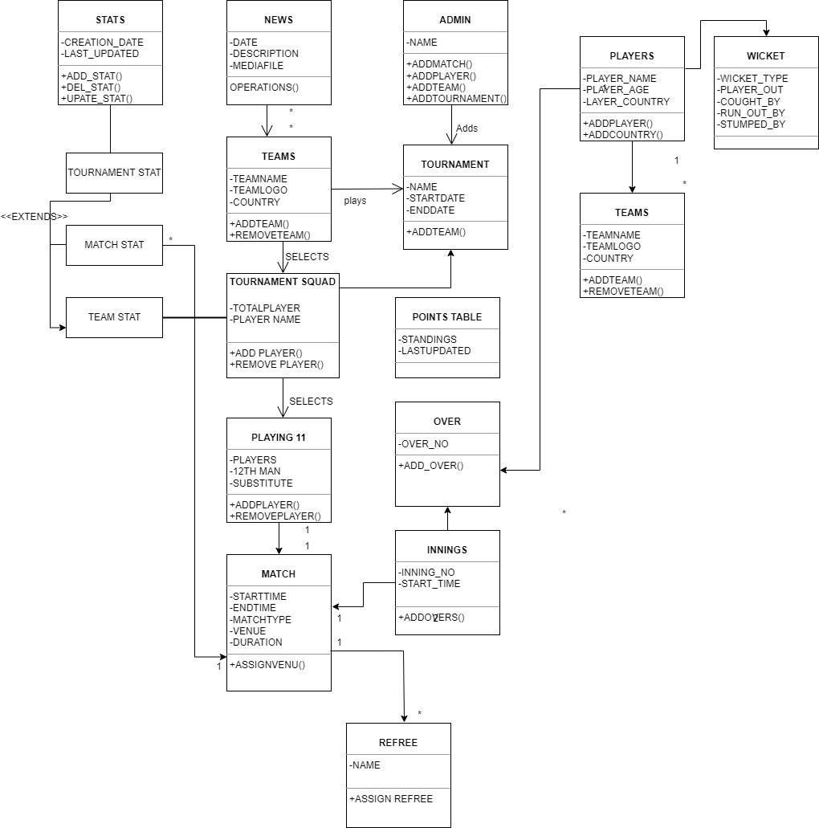 **Figure 1.1 Class Diagram**

### Sequence Diagram

### Figure 1.2 Sequence Diagram

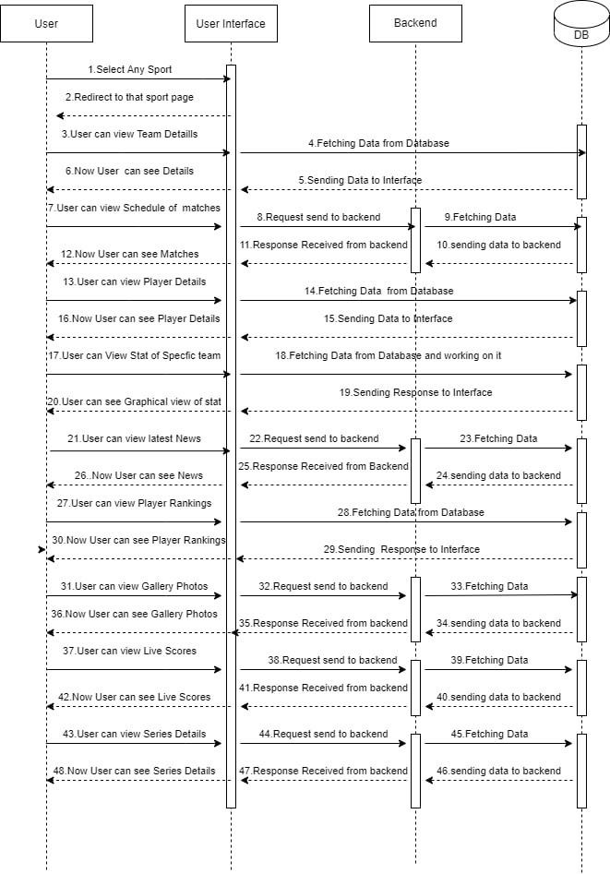

### Use case Diagram

### Figure 1.3 Use case Diagram

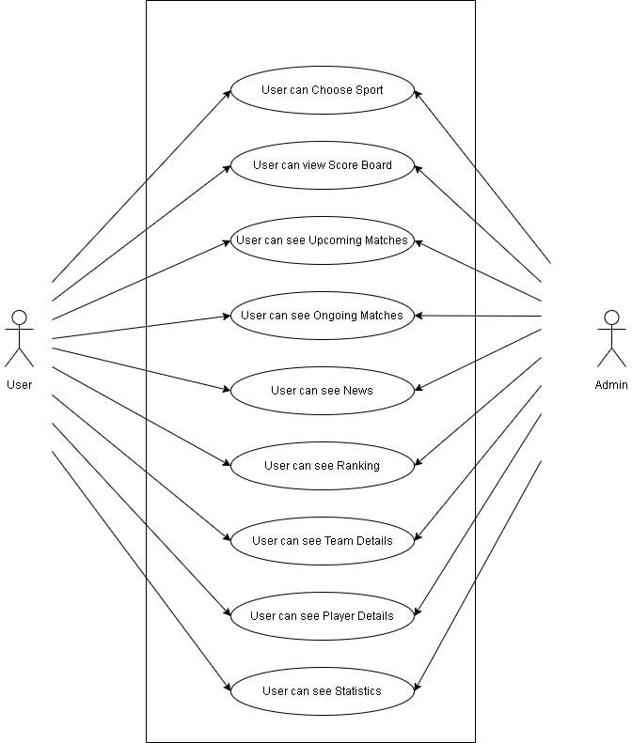

### Wireframes

### 

**Figure 1.4.1 Home page screen**

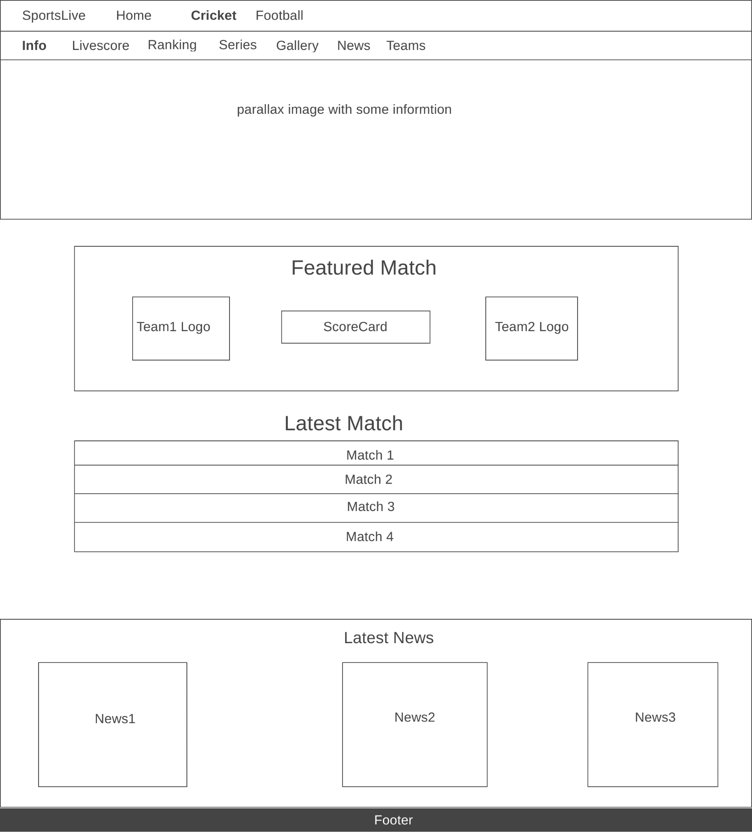

**Figure 1.4.2 Cricket Home page screen**

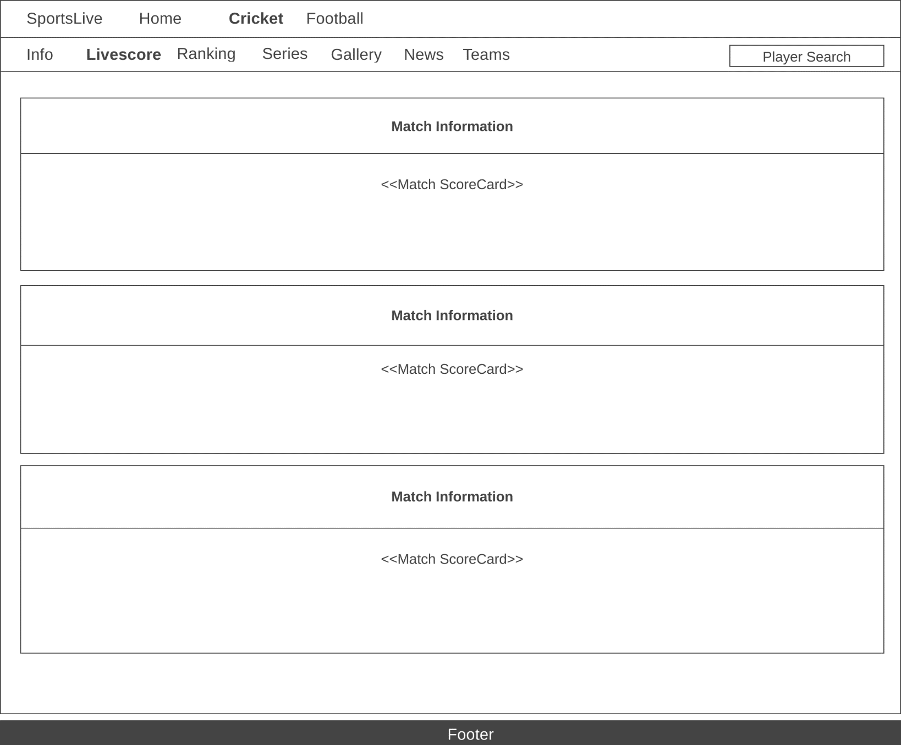

**Figure 1.4.3 Screen for cricket Live score**

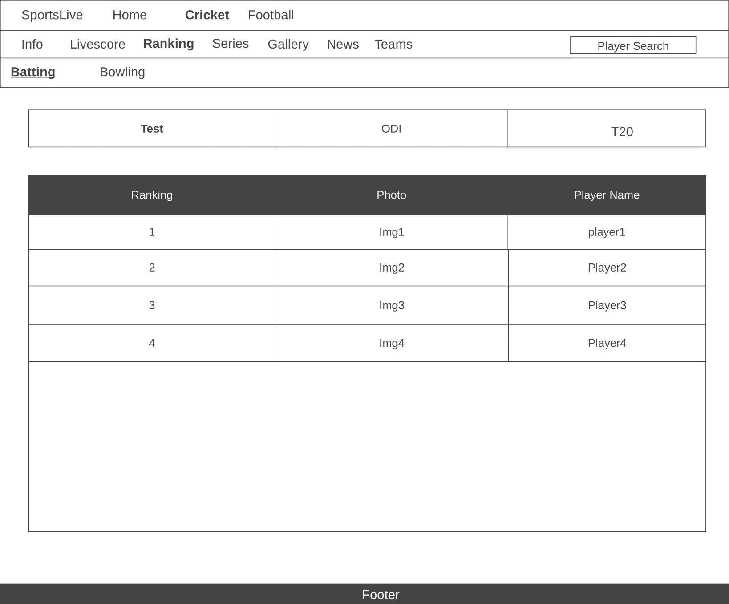

**Figure 1.4.4 Screen for Cricket Schedule**

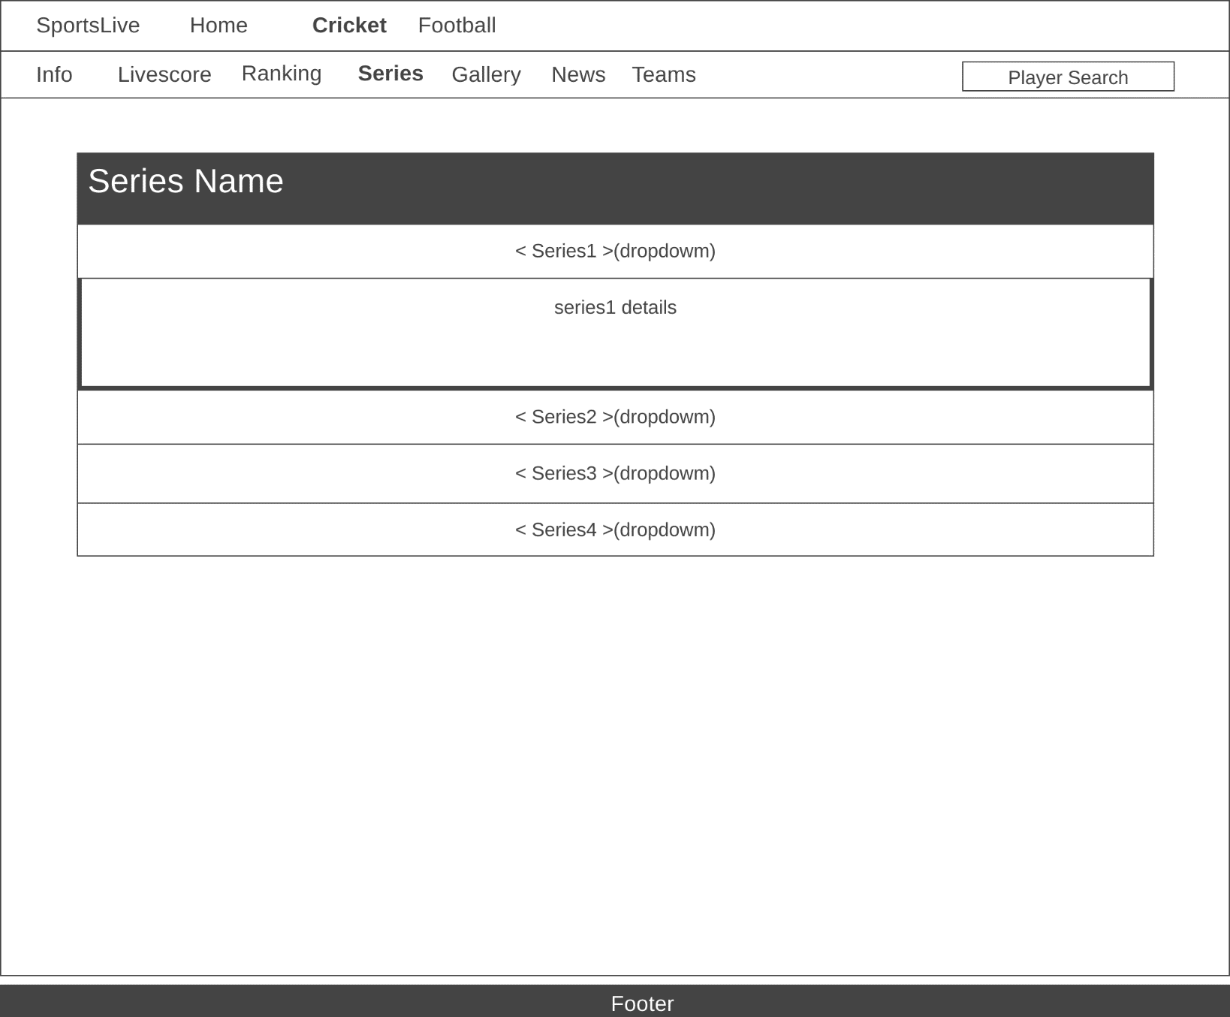

**Figure 1.4.5 Screen for Cricket Series**

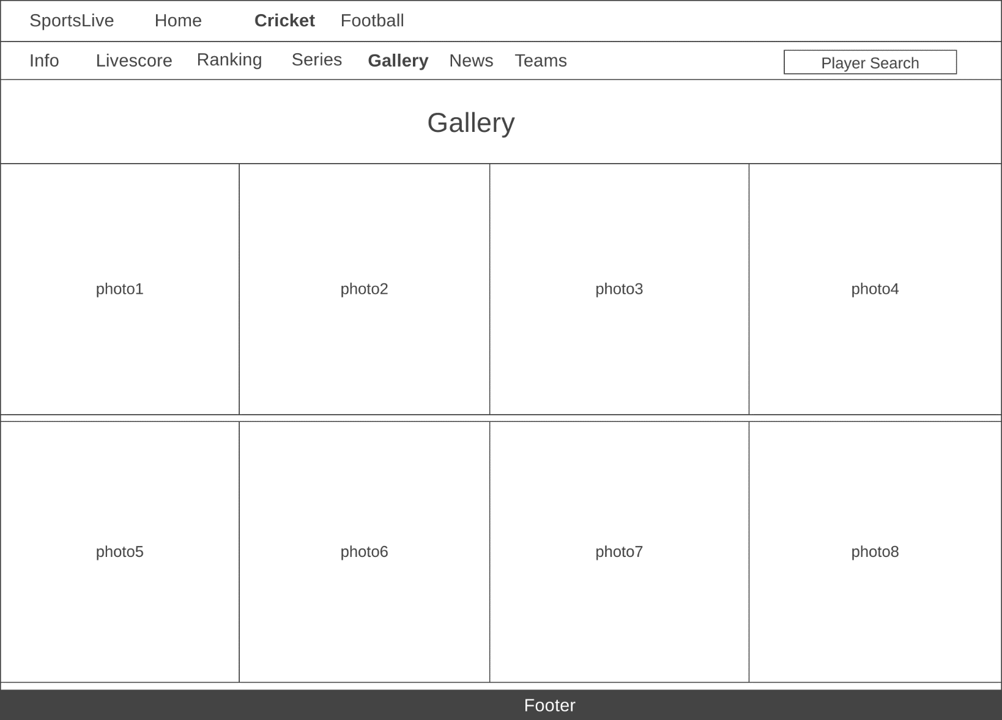

**Figure 1.4.6 Screen for Cricket Gallery**

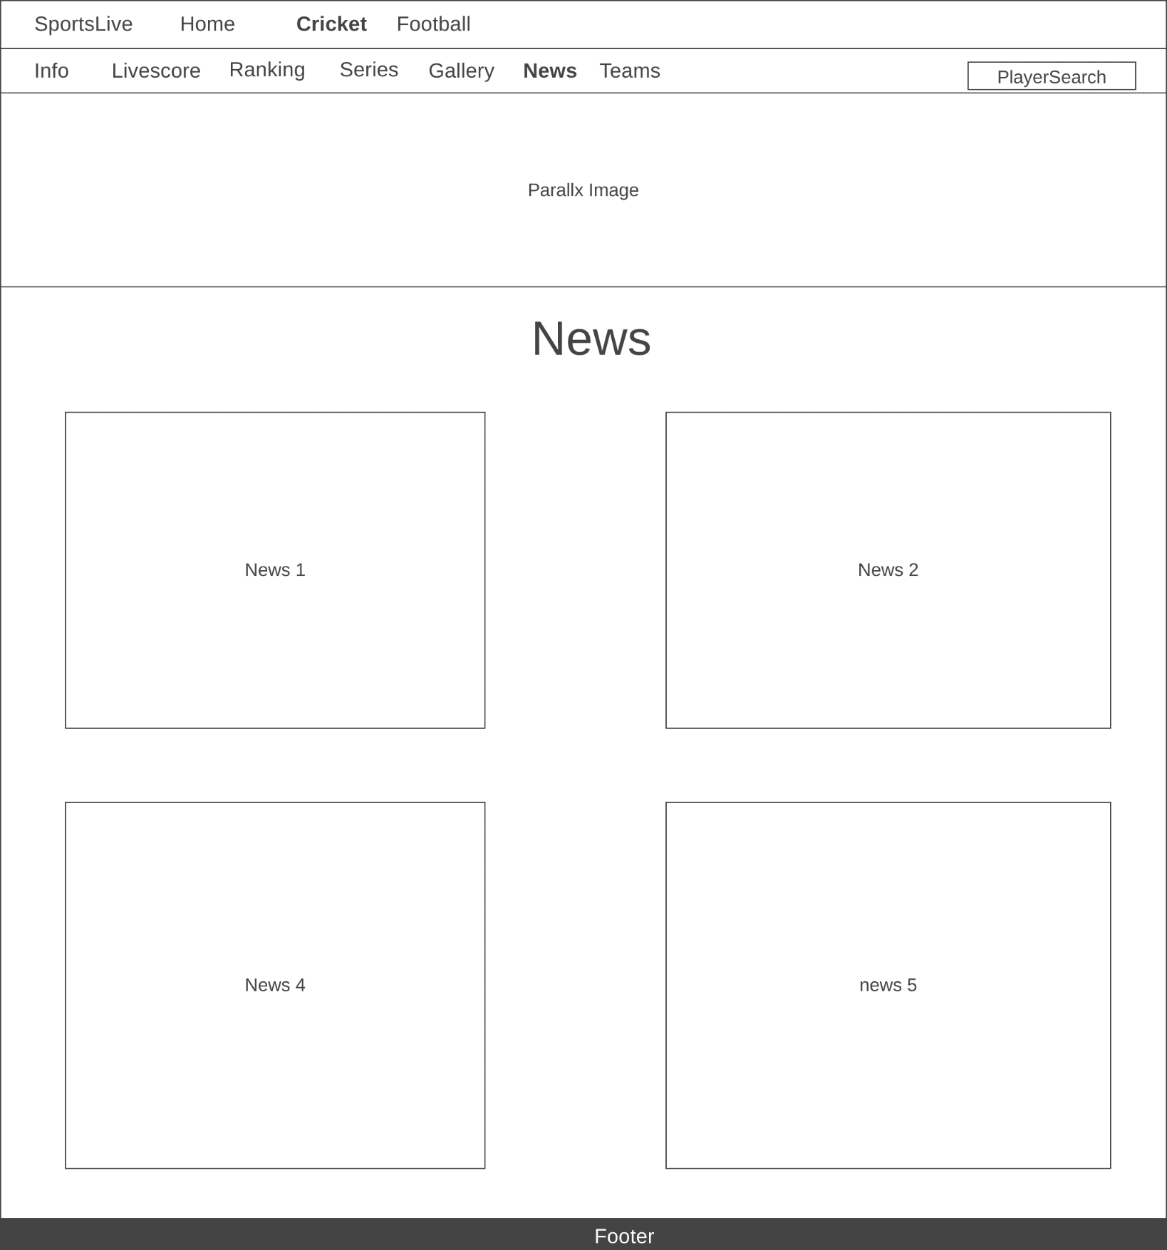

**Figure 1.4.7 Screen to Cricket News**

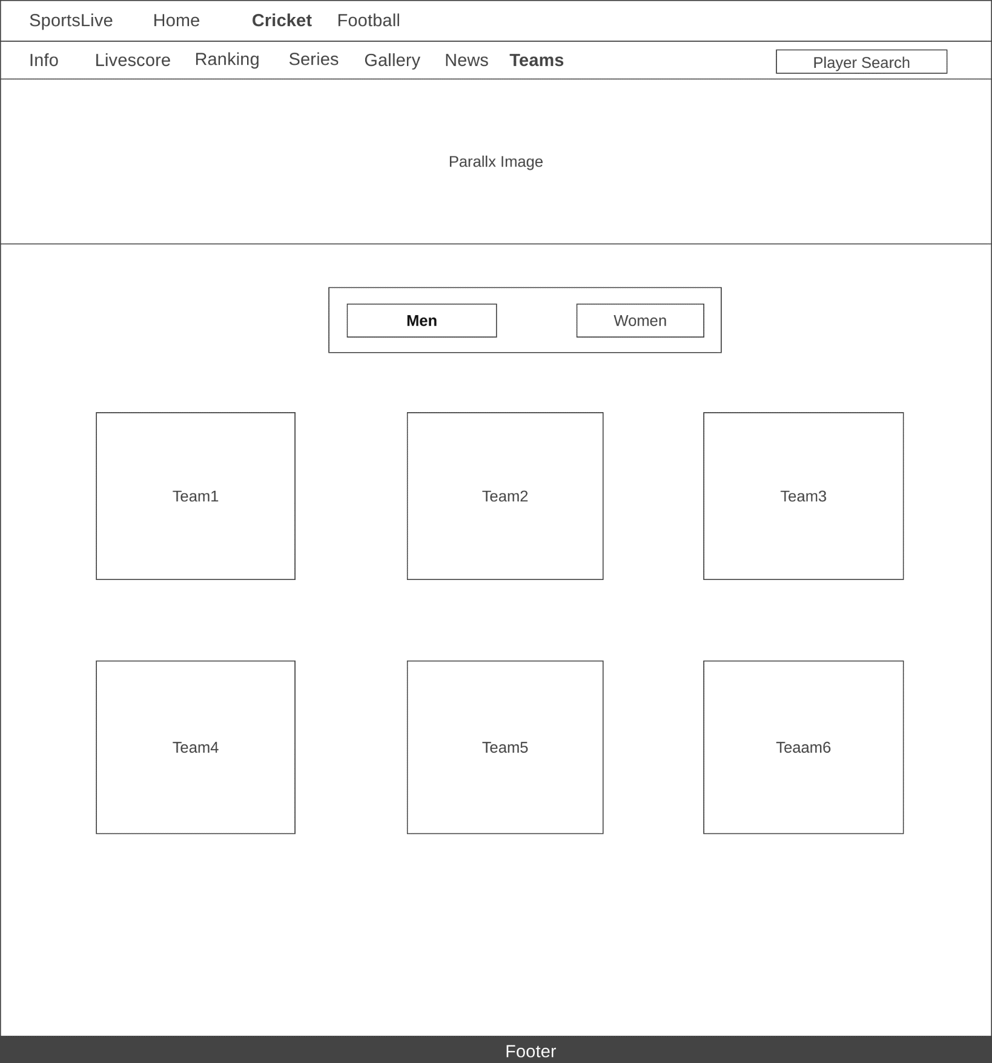

**Figure 1.4.8 Screen for Cricket Teams**

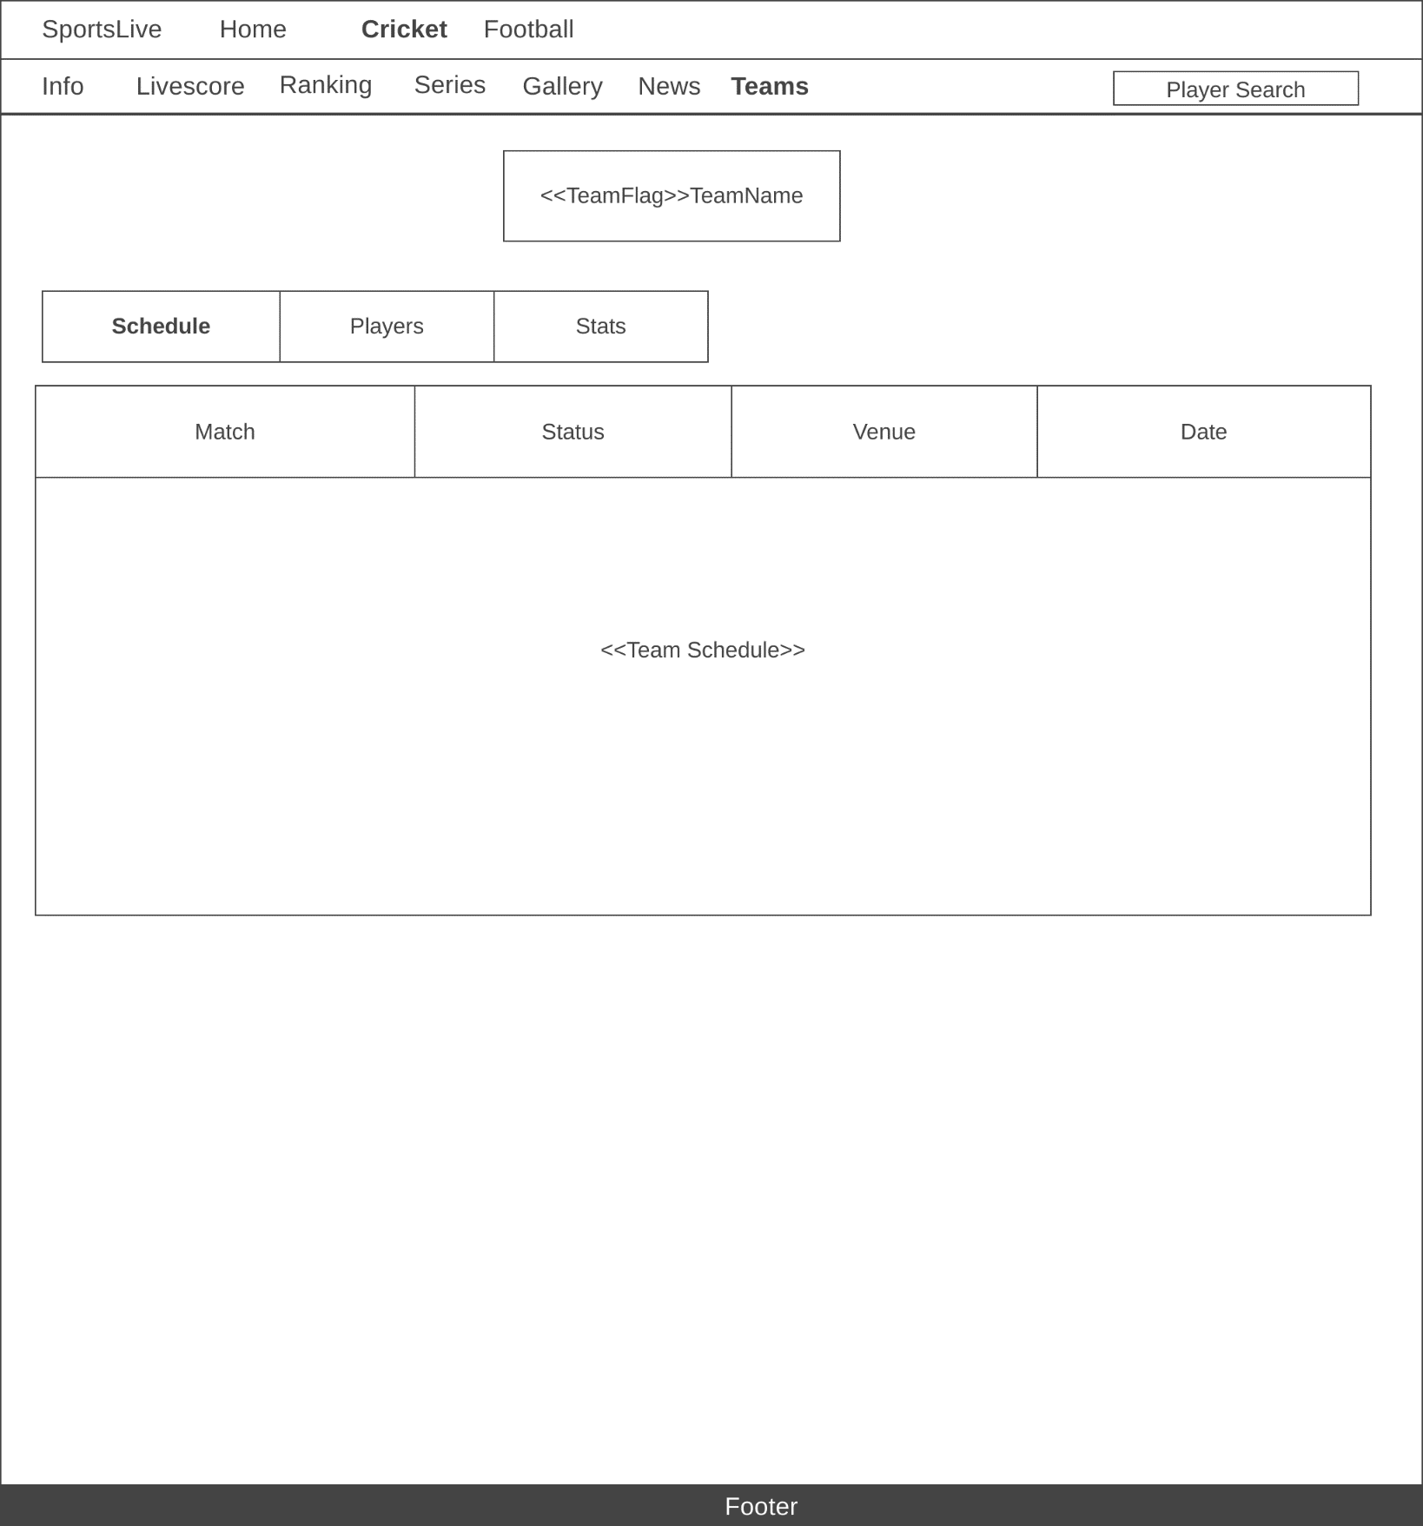

**Figure 1.4.9 Screen for Cricket Teams Schedule**

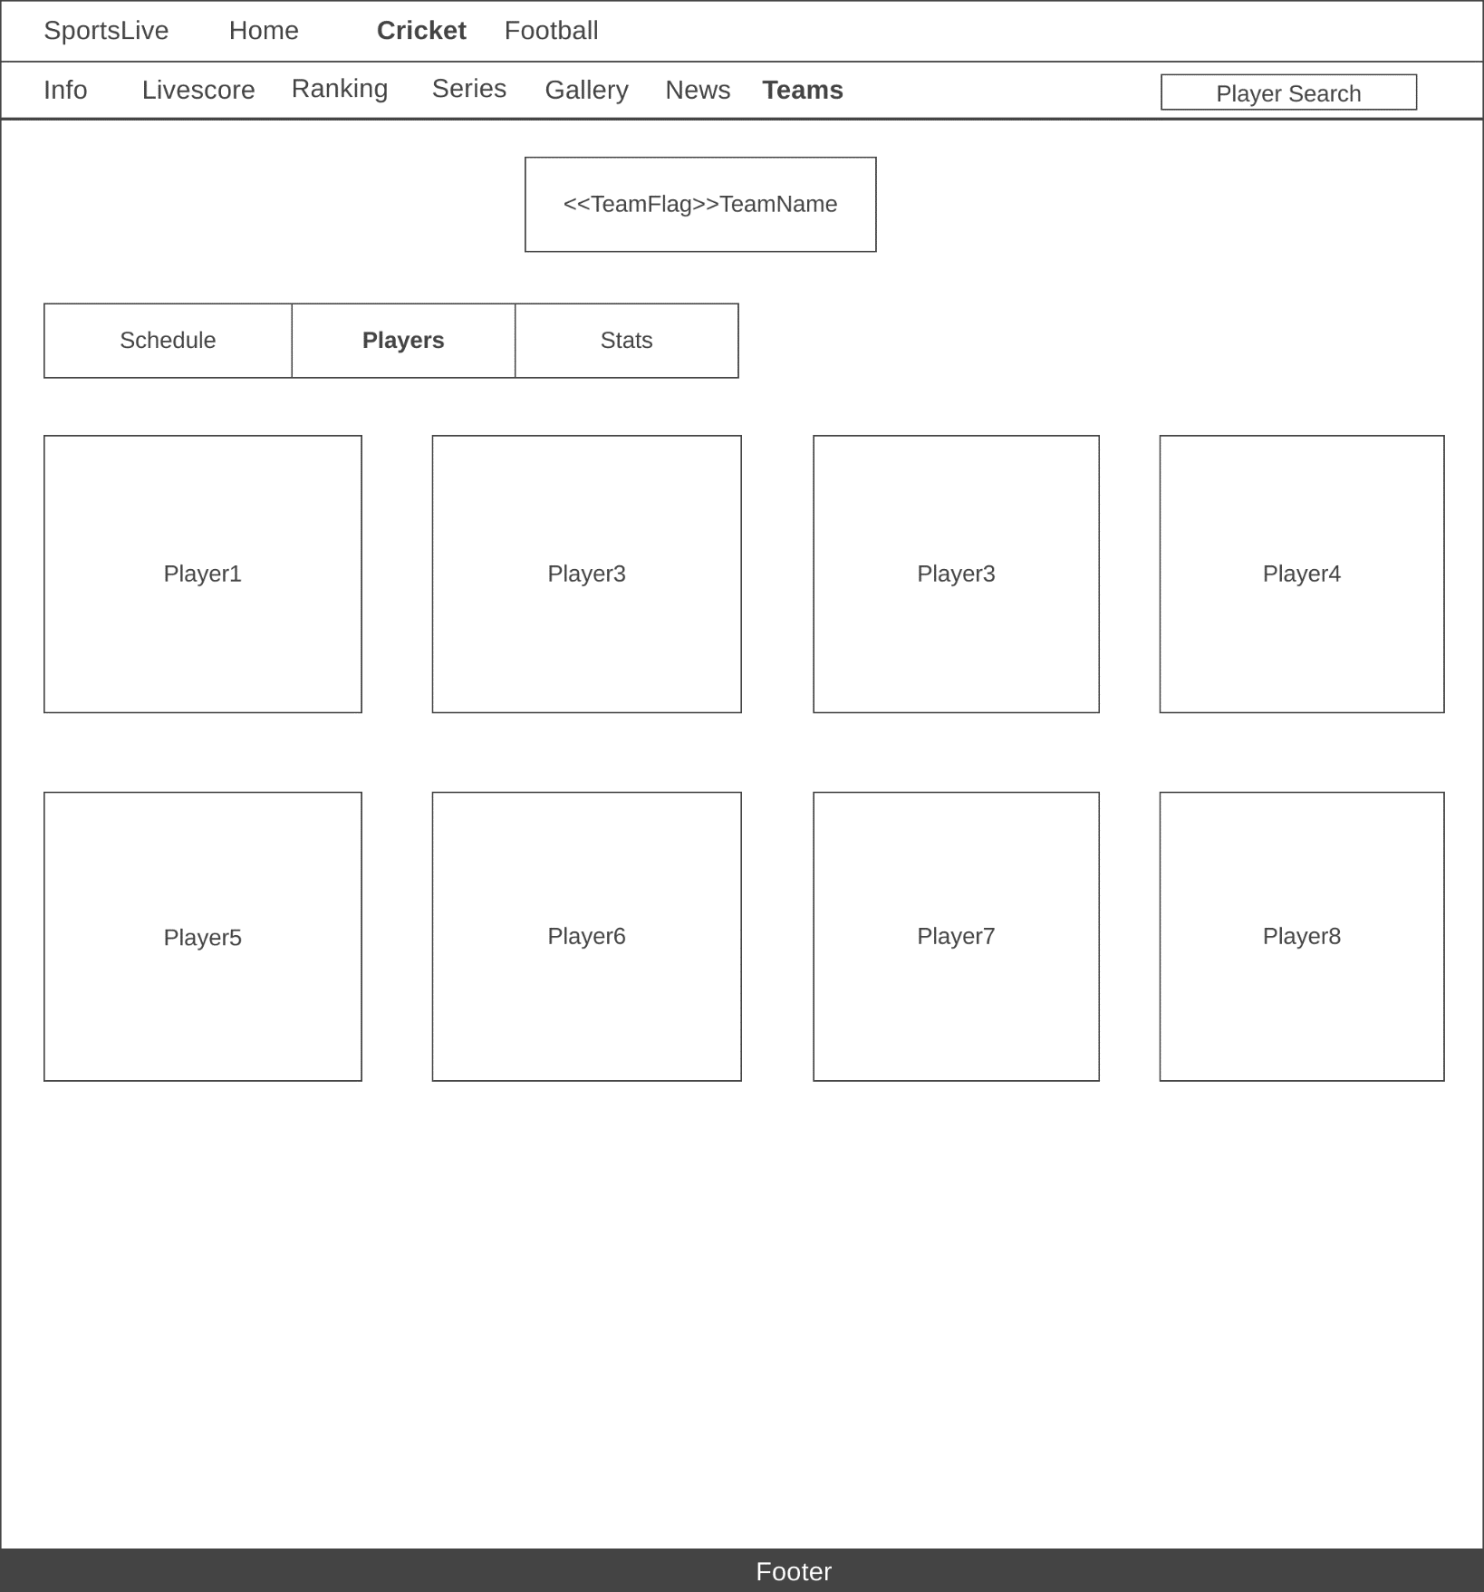

**Figure 1.4.10 Screen for Cricket Teams Players**

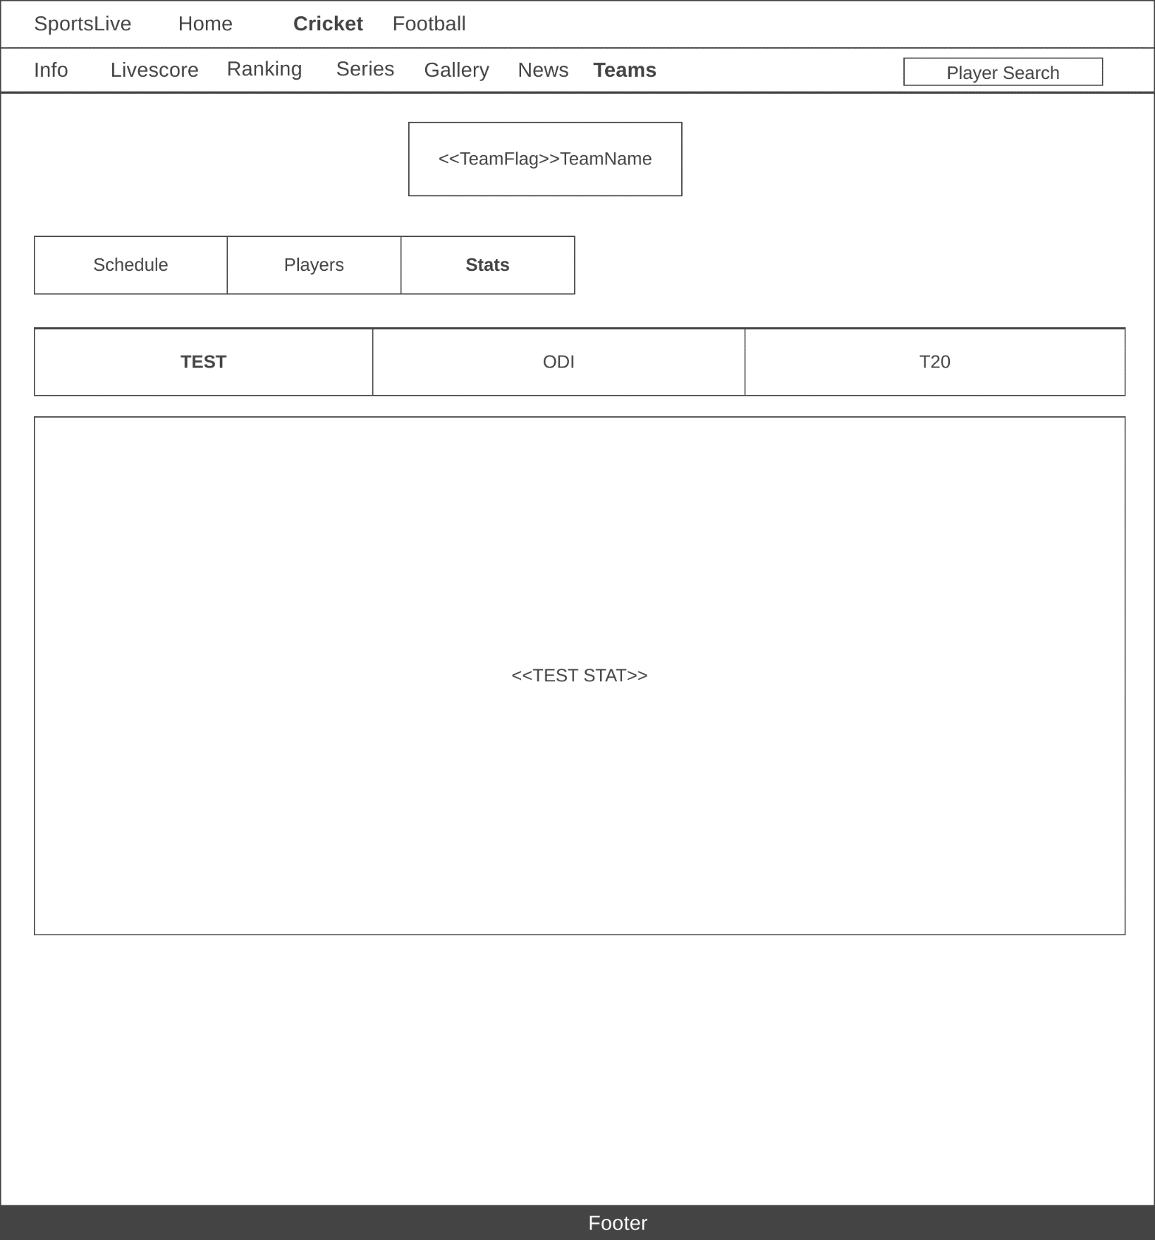

**Figure 1.4.11 Screen for Cricket Teams Stats**

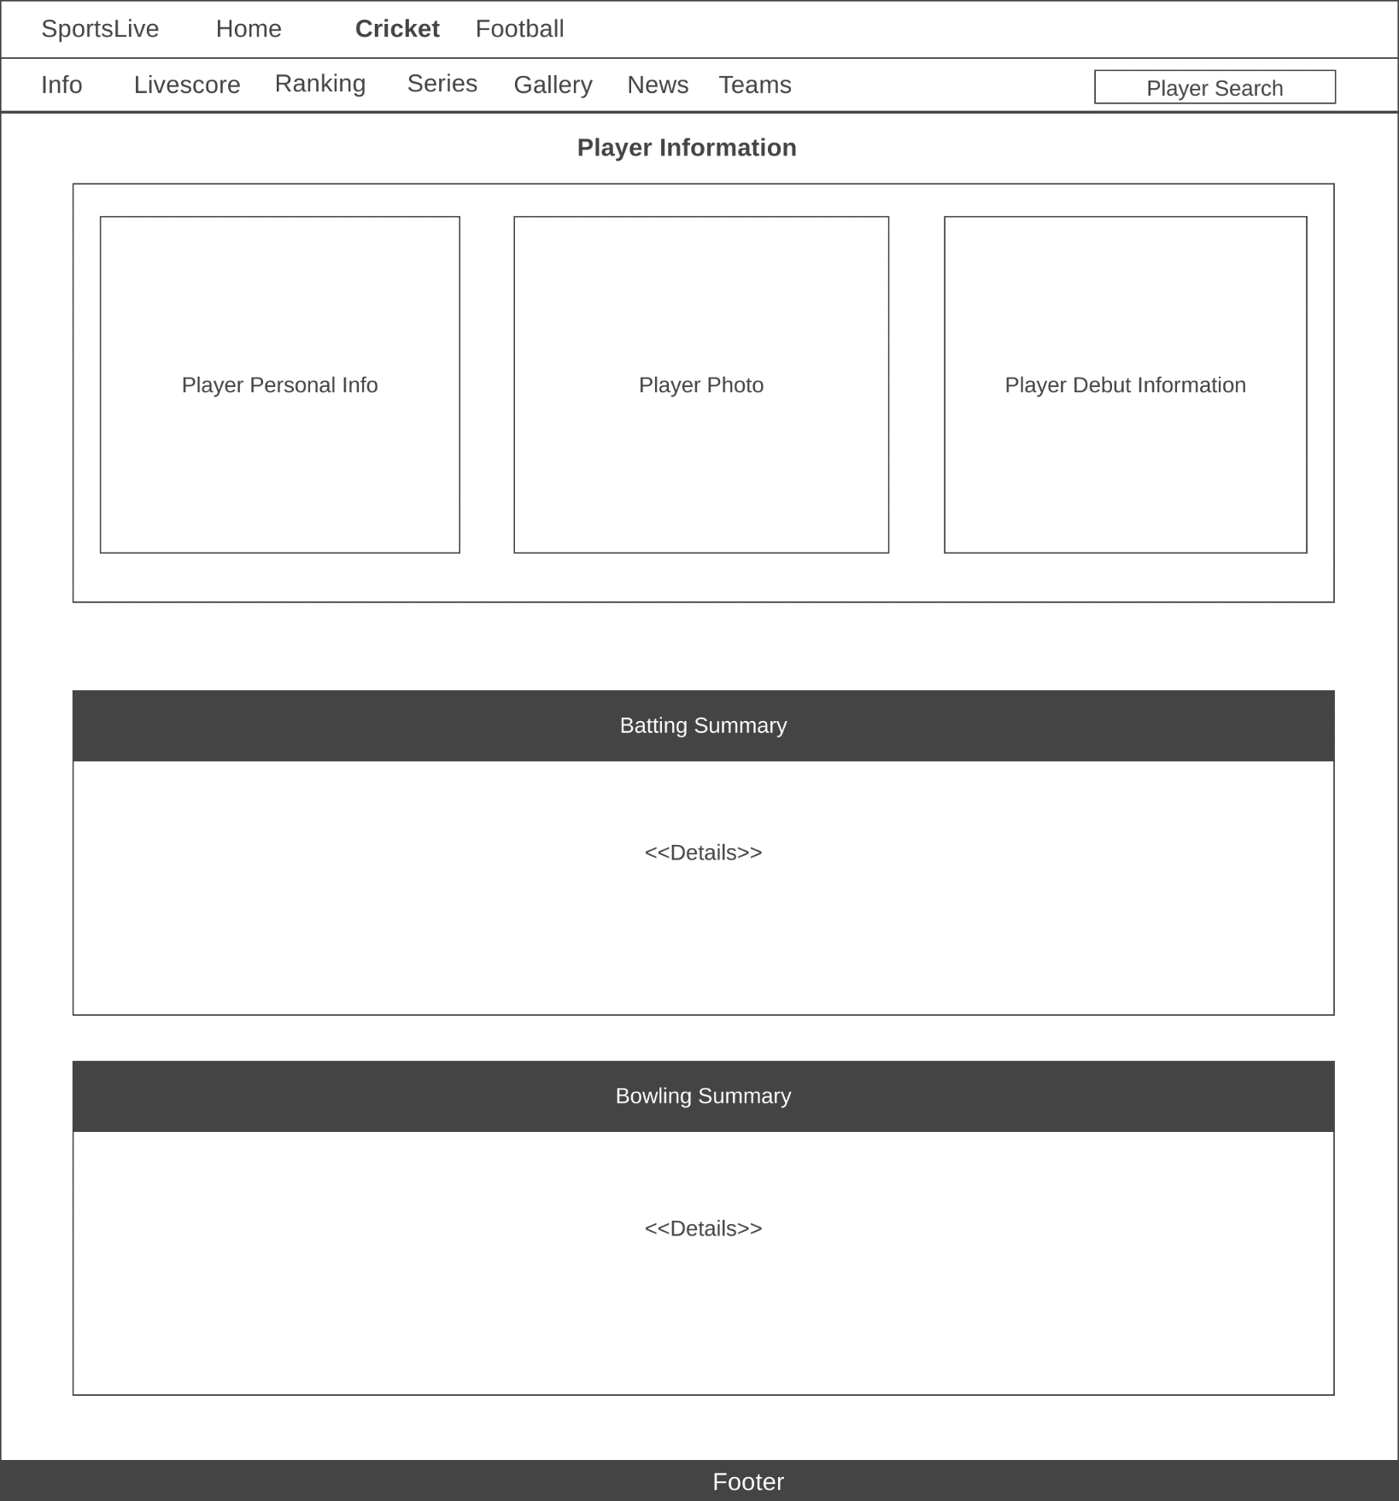

**Figure 1.4.12 Screen for Cricket Teams Player Info**

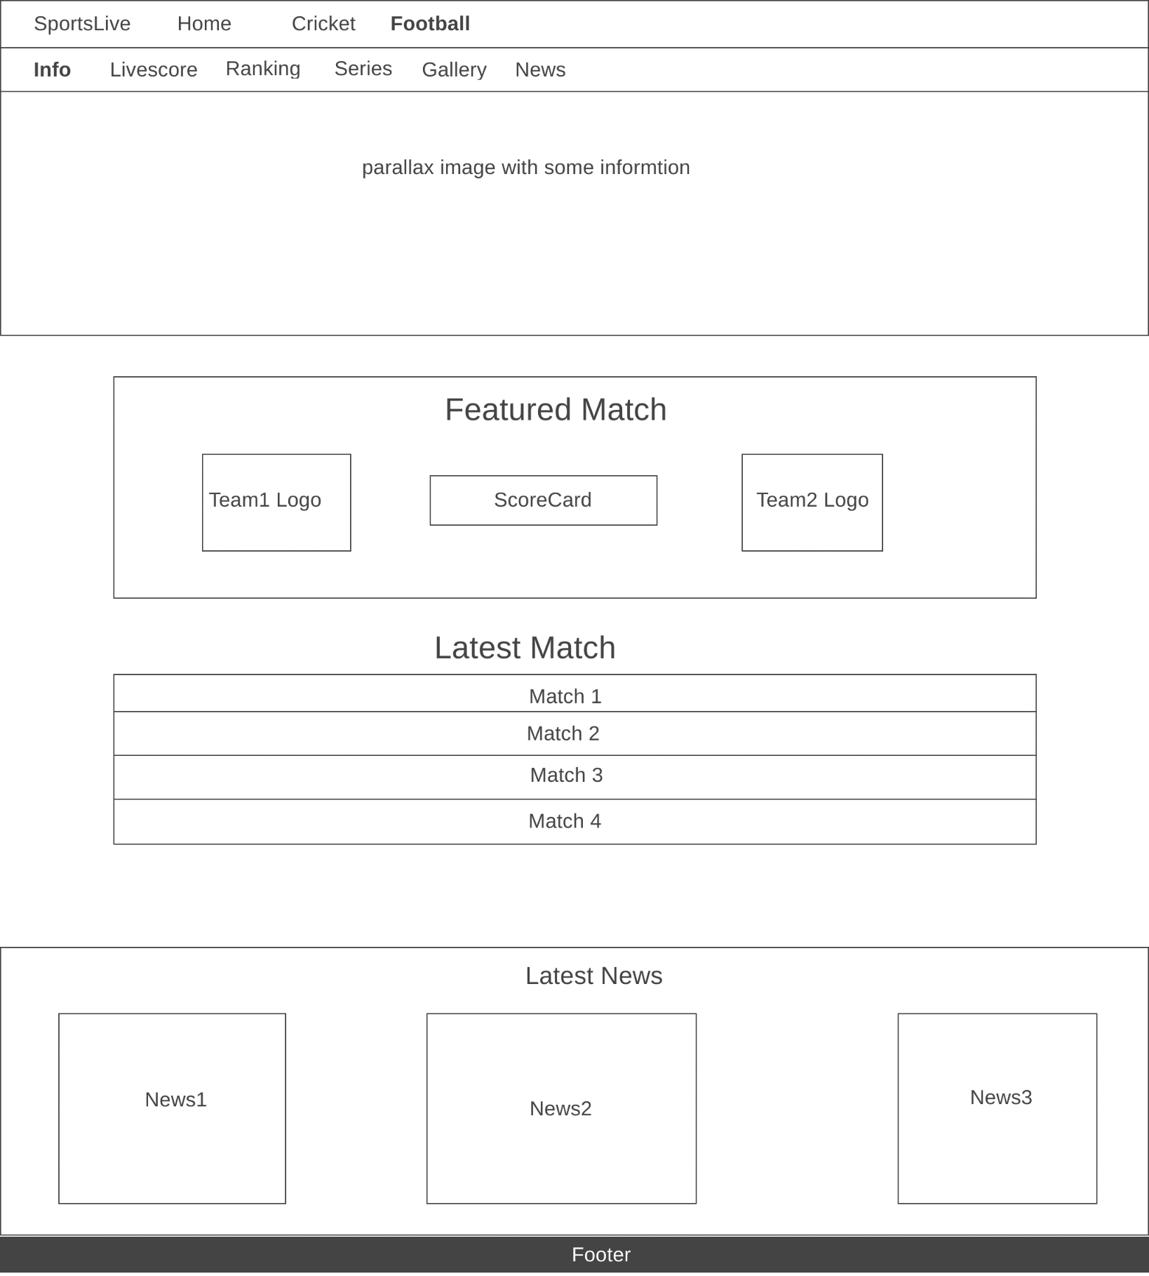

**Figure 1.4.13 Screen for Football Landing Page**

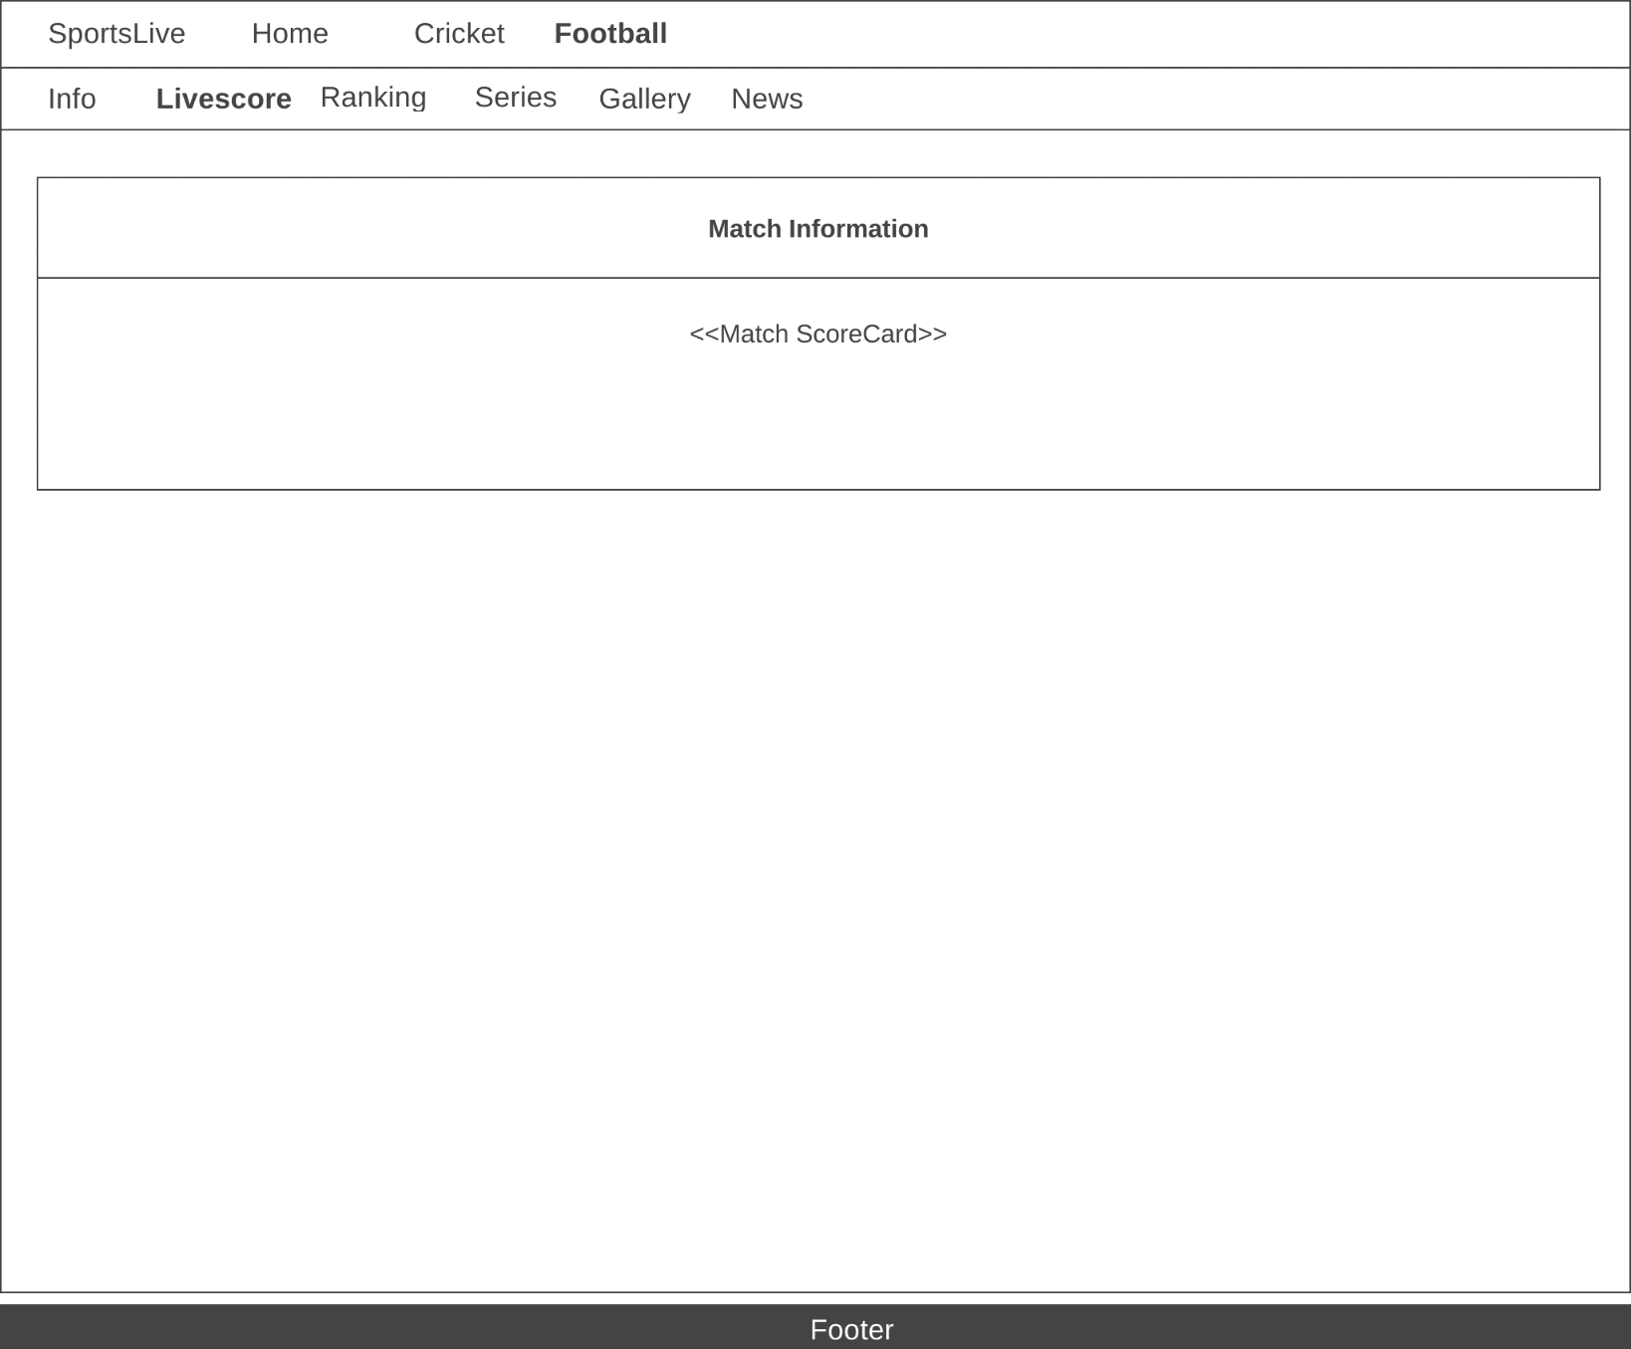

**Figure 1.4.14 Screen for Football Live Scores**

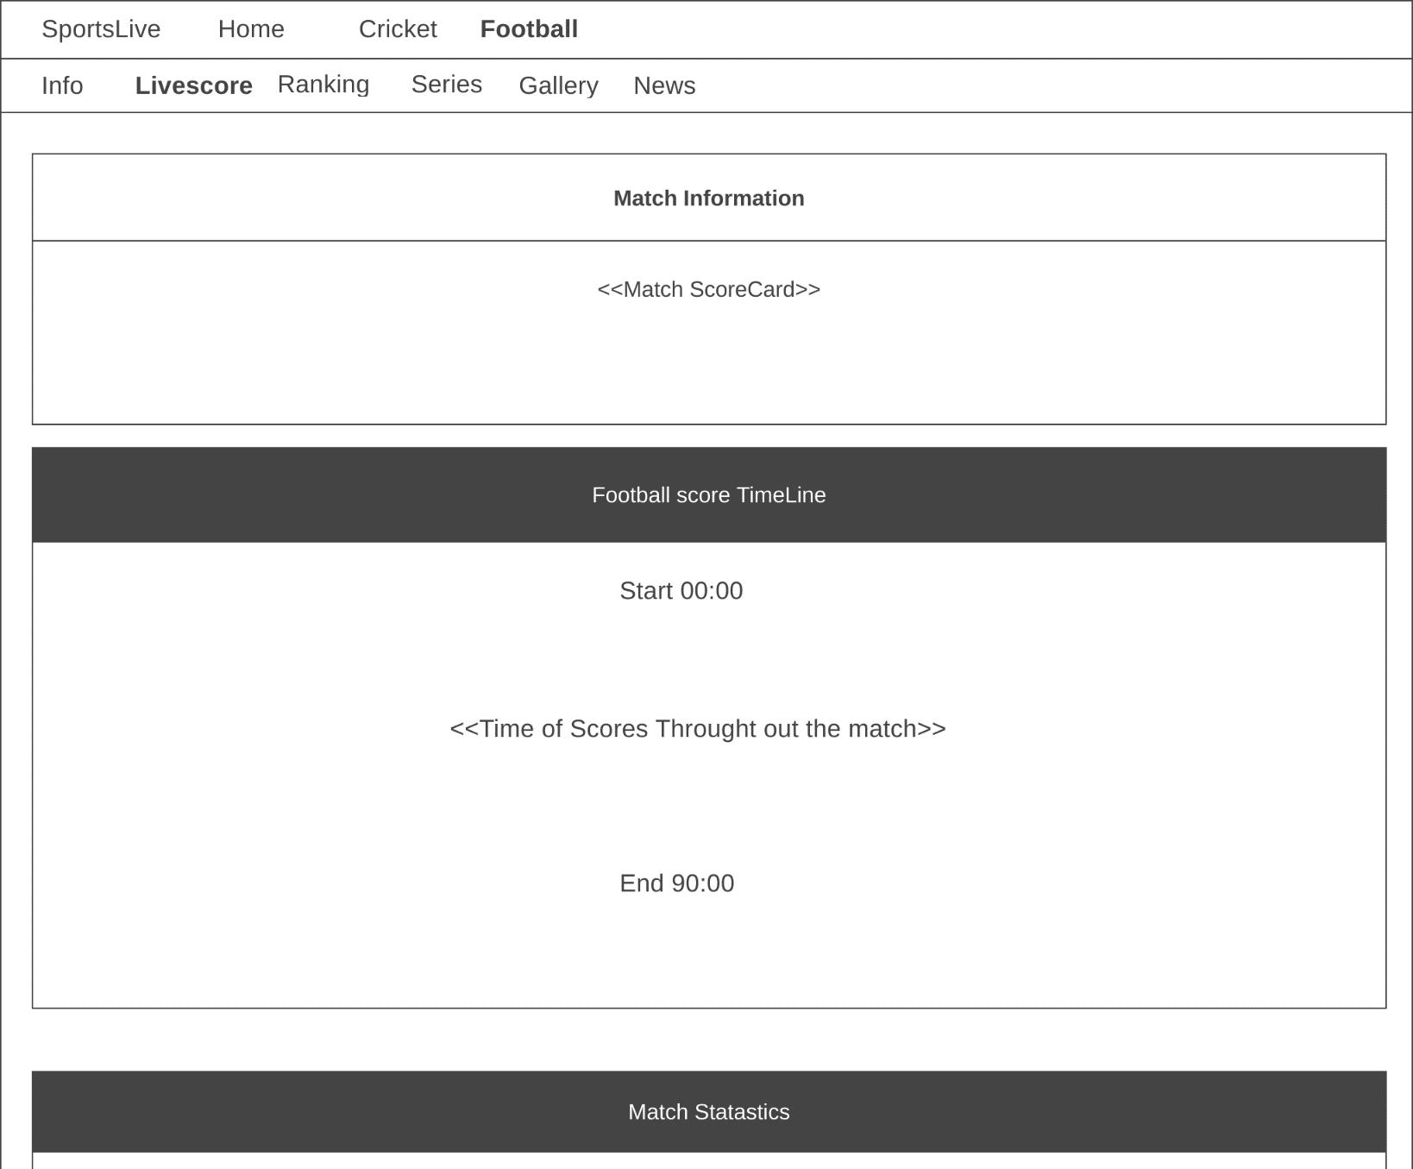

**Figure 1.4.15 Screen for Football Match Summary**

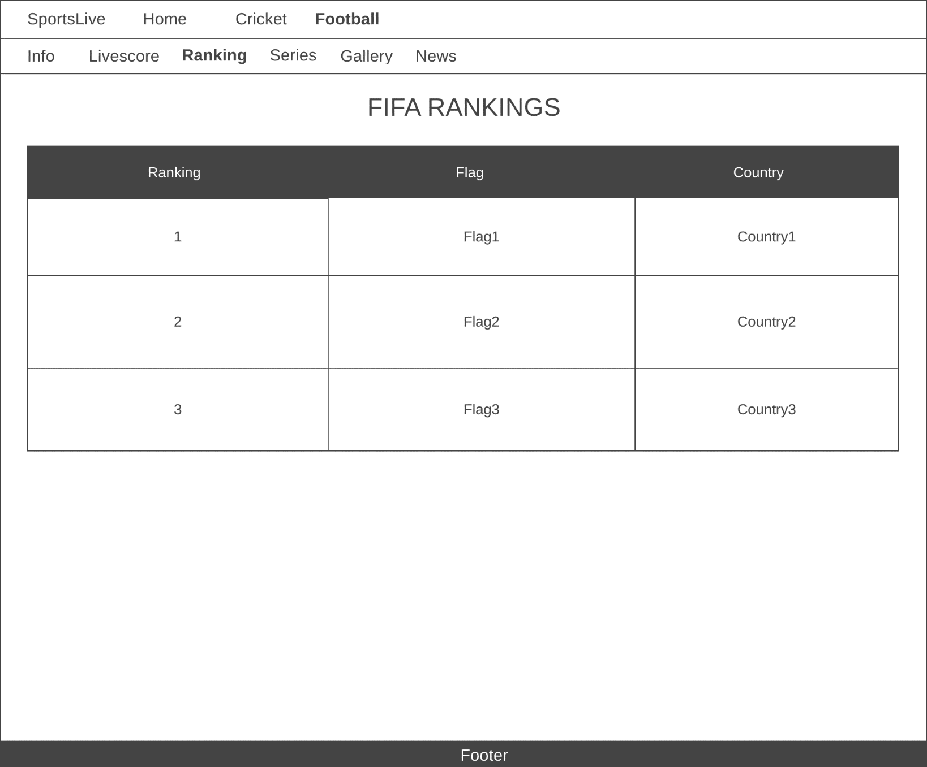

**Figure 1.4.16 Screen for Football Rankings**

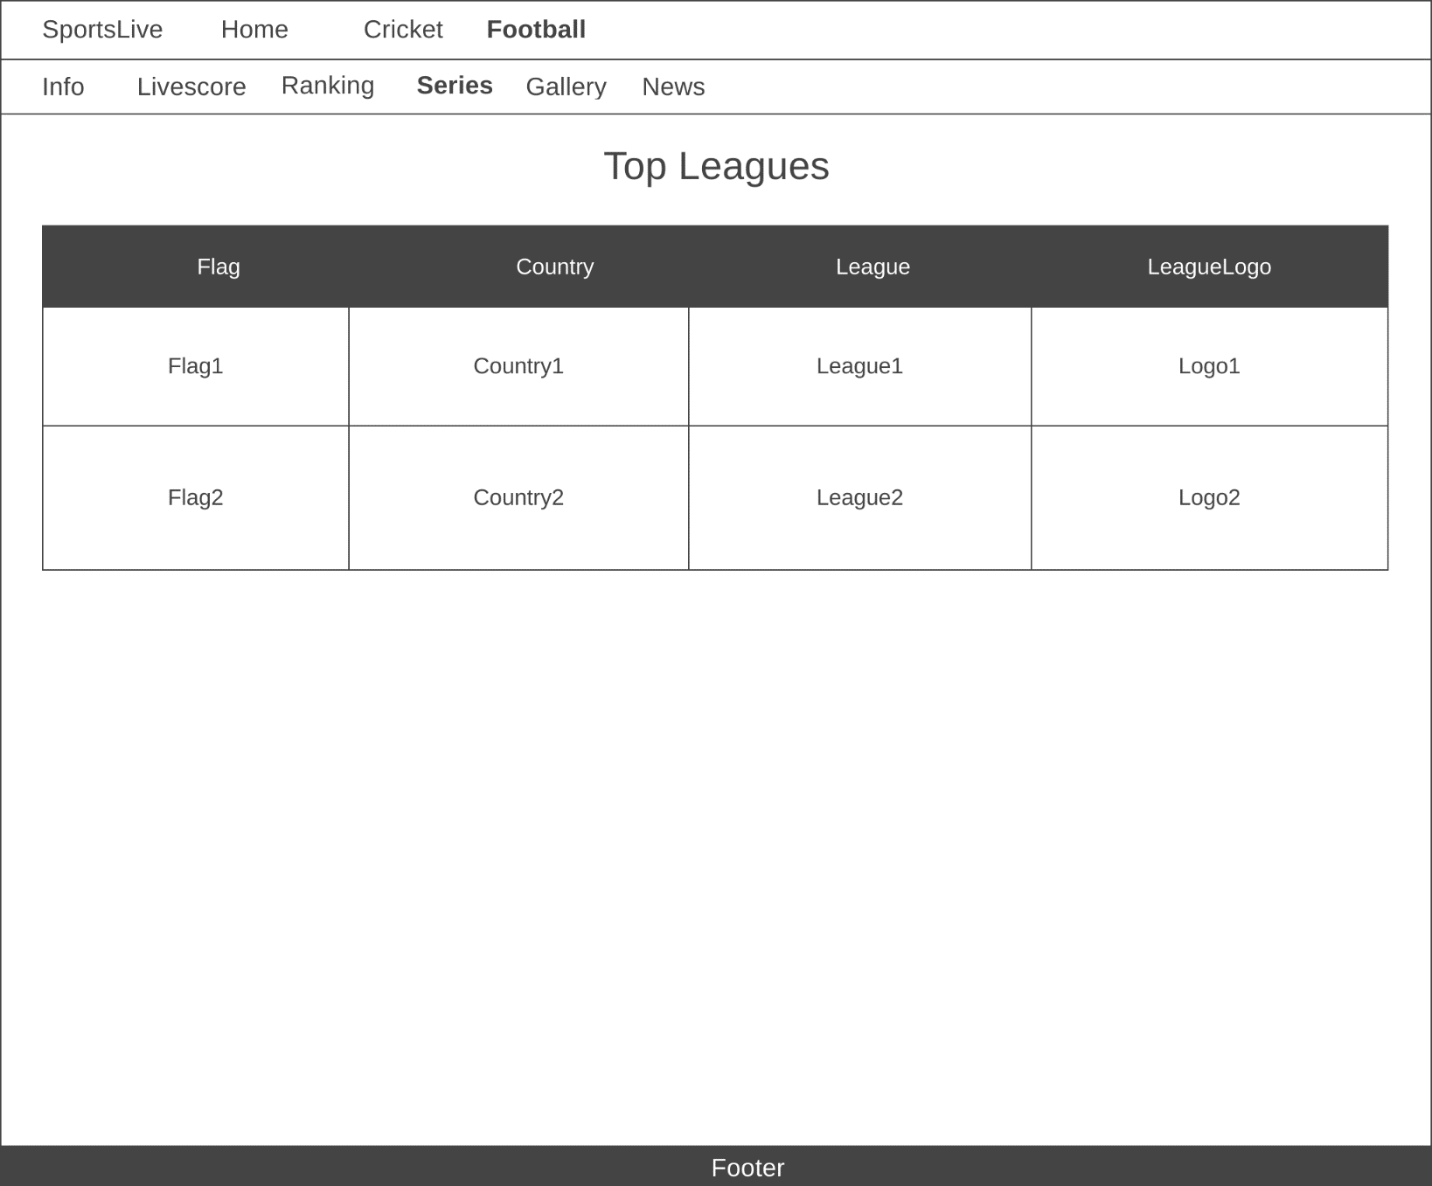

**Figure 1.4.17 Screen for Football Leagues**

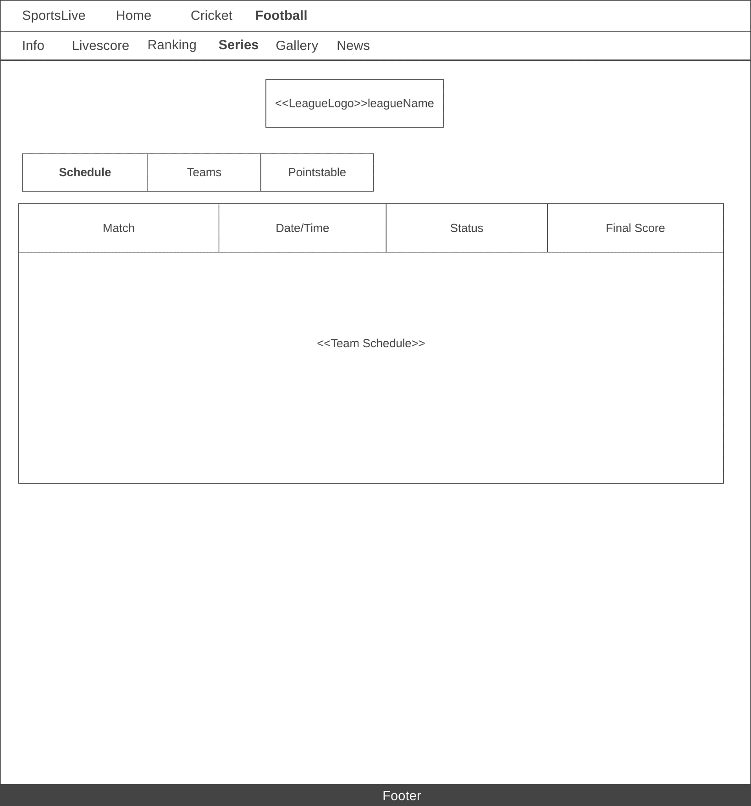

**Figure 1.4.18 Screen for Football League Schedule**

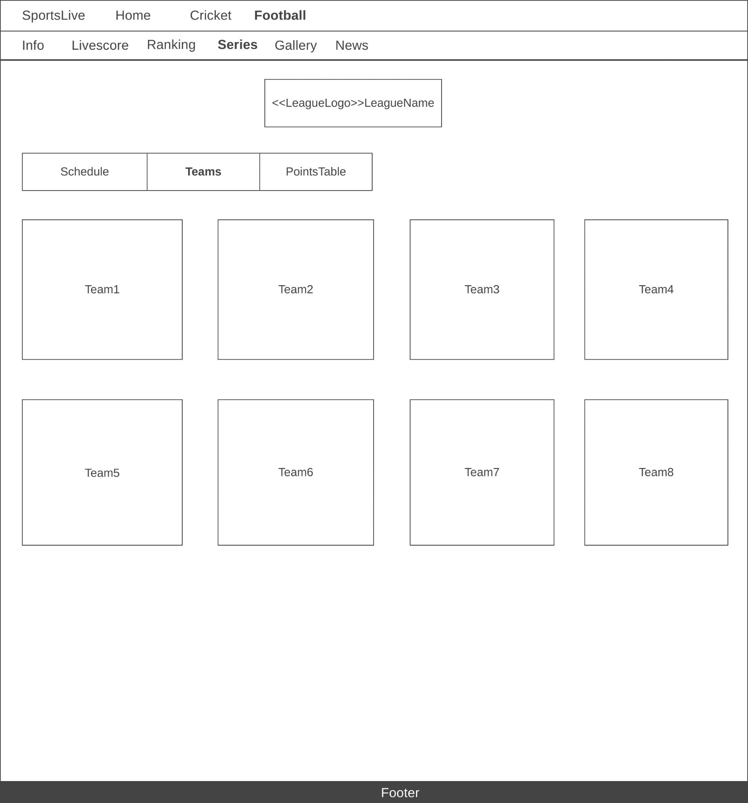

**Figure 1.4.19 Screen for Football League Teams**

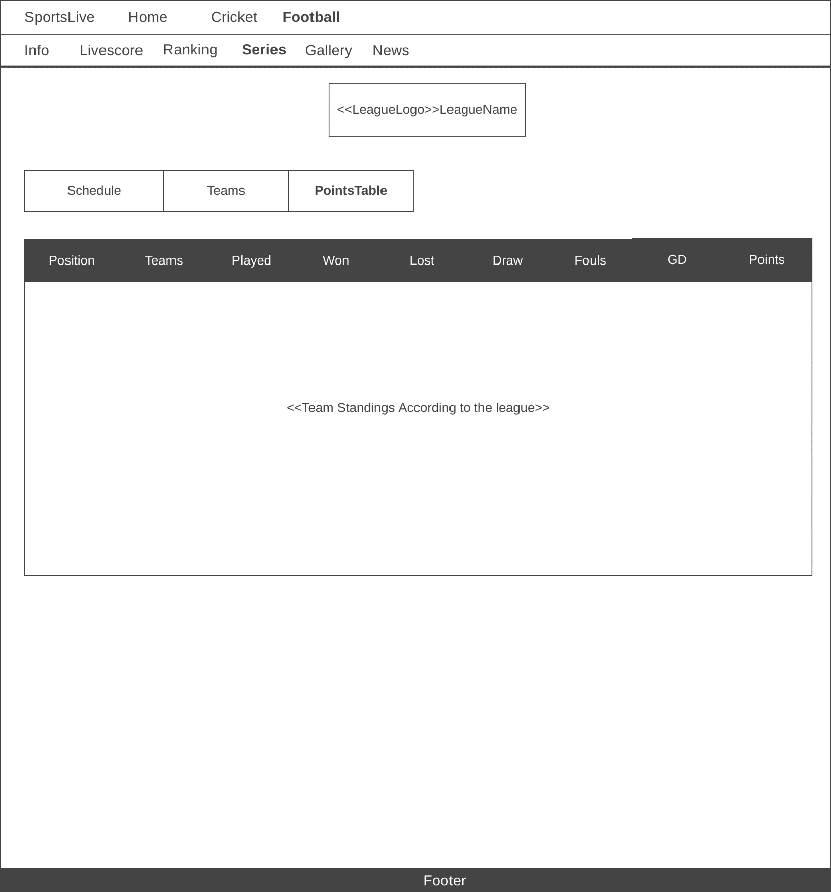

**Figure 1.4.20 Screen for Football League points Table**

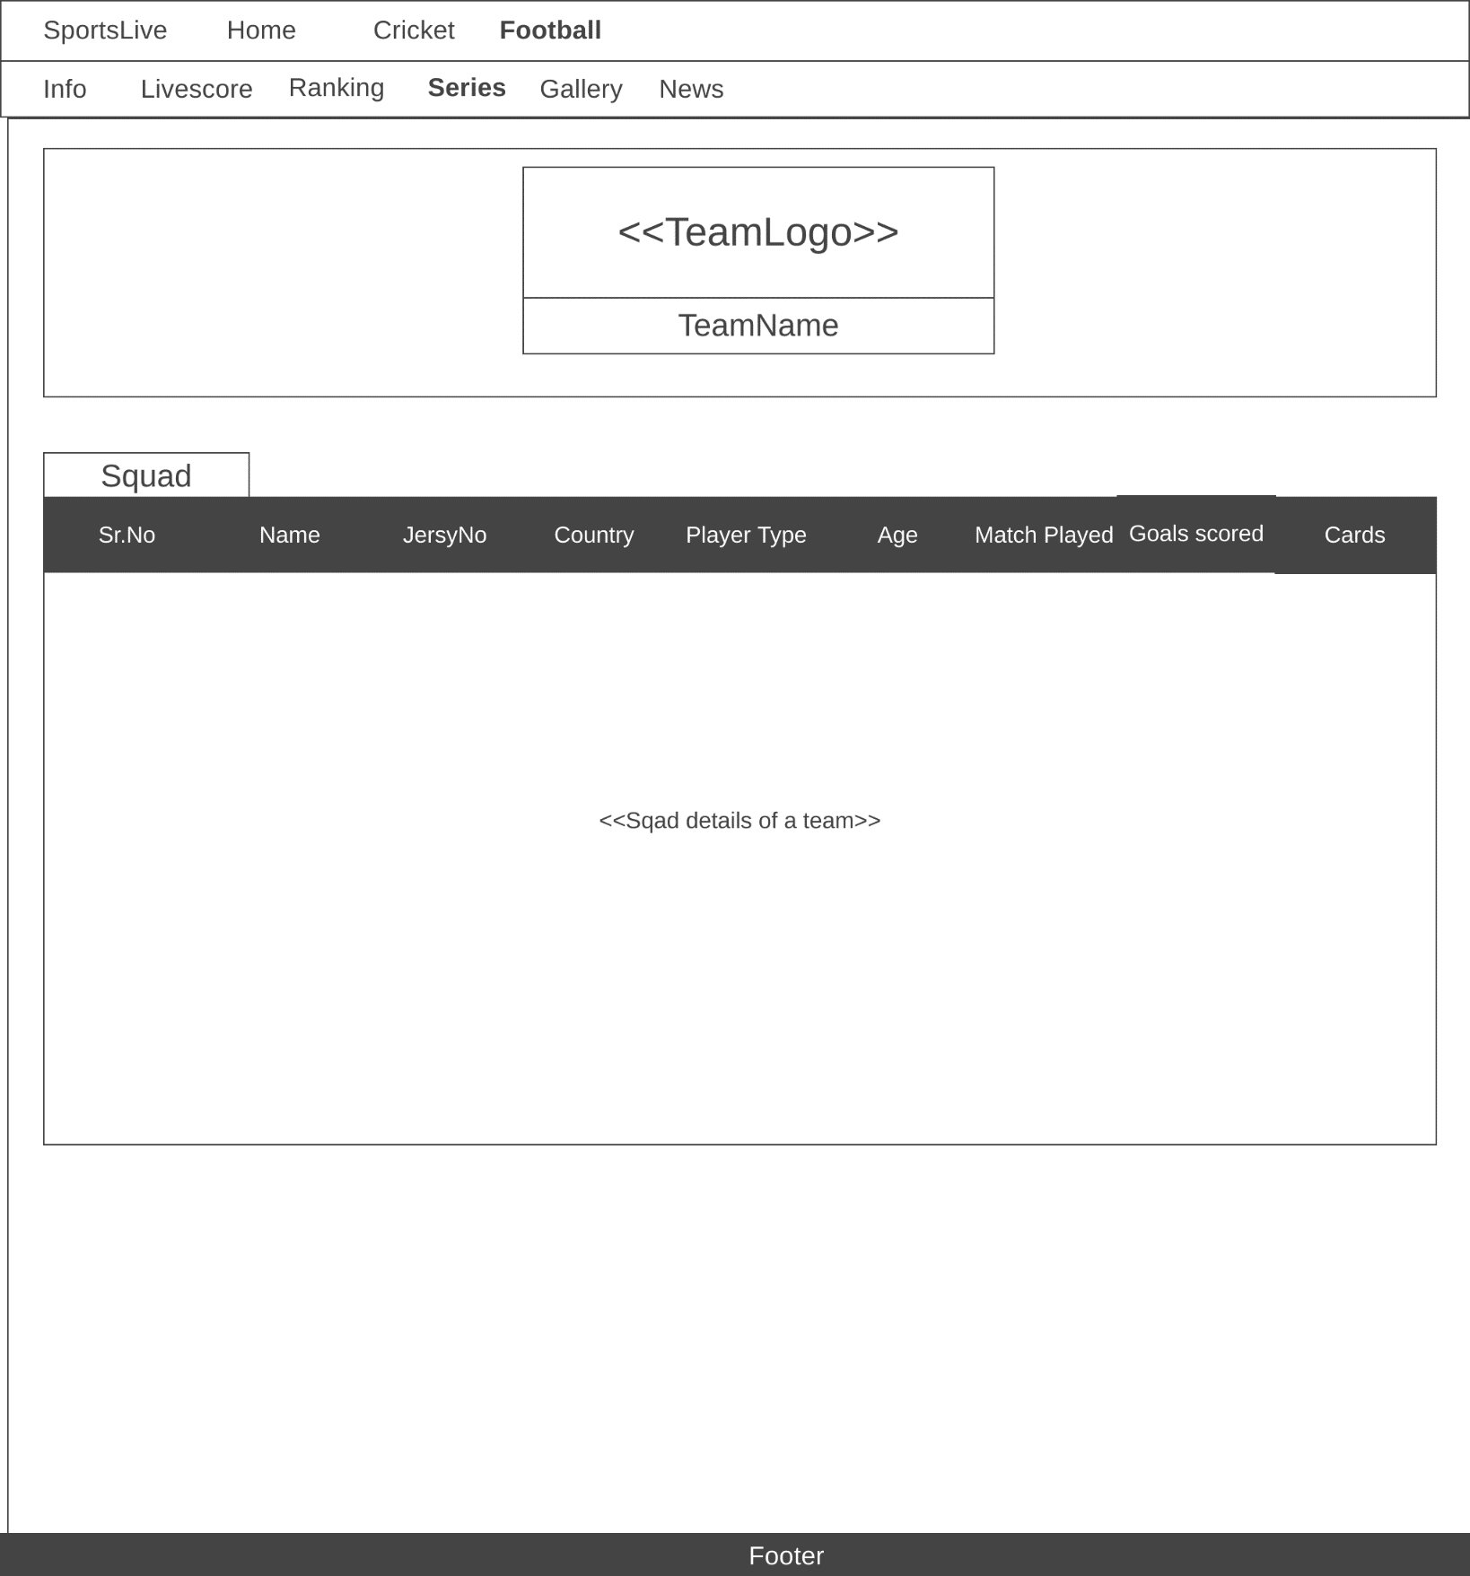

**Figure 1.4.21 Screen for Football Team Details**

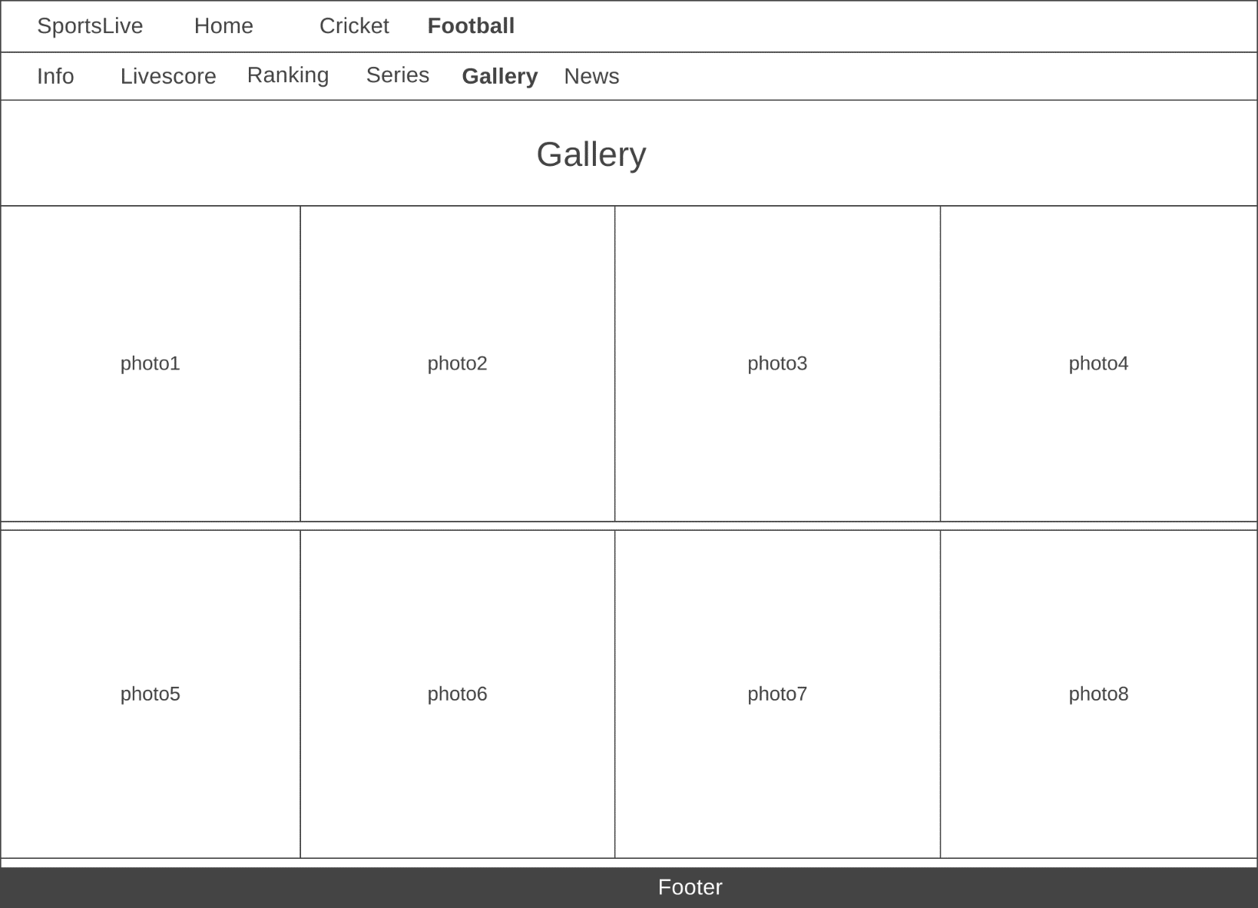

**Figure 1.4.22 Screen for Football Gallery**

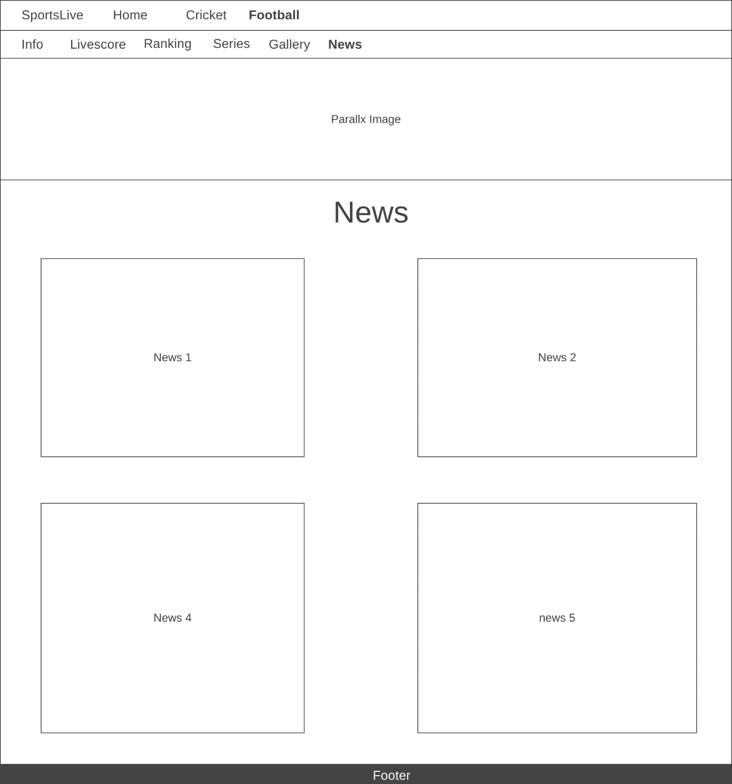

**Figure 1.4.23 Screen for Football News**

# Development

### Table 1.7 Application Features

|  |  |  |
| --- | --- | --- |
| **Role** | **Must have features** | **Nice to have features** |
| User | -Cricket home page | -live commentary |
|  | -Live scores | -online shopping |
|  | -Team details | -booking tickets |
|  | -Player ranking |  |
|  | -Gallery |  |
|  | -Schedule matches |  |
|  | -Player details |  |
|  | -Player runs statistics using graphs |  |
|  | -News about cricket |  |
|  | -Search by player name |  |
|  | -Football home page | - live commentary |
| -Live scores | -online shopping |
| -Leagues list | -booking tickets |
| -Leagues details | -player details |
| -List of matches under a particular league |  |
| -Ranking of team |  |
| -Gallery |  |
| -News about football |  |
| -Graphs on match data |  |

# Testing

This section is used to check whether the actual software product matches expected requirements and to ensure that software product is defect free. Here testing is performed to identify errors, gaps or missing requirements in contrast to actual requirements.

### Importance of Testing

Testing enables to describe, the quality of software products or services provided to the customers on improving the software development process and making it efficient and effective as per the quality standards defined for software products

### Test Cases

This section conveys information about, the different test cases identified for each component of this application. They are as described as follows, 124

### UI Testing

#### Test Case: UX01

Test case description:

To verify that search provides a desired result to the user

**Total 1.8.1 Cricket Home Page – Search Bar**

|  |  |  |  |  |
| --- | --- | --- | --- | --- |
| Step No. | Step Description | Test Data | Expected Result | Actual Result |
| 1. | On cricket home page user will search for player. | Invalid player name | Nothing will display. | Nothing displayed. |
|  |  | Valid player name | Player data will be display in tabular format. | Player data will be display in tabular format. |

#### Test Case: UX02

Test case description:

To verify that a correct data is displayed after user click on Teams tab.

**Table 1.8.2 Cricket Home Page – Team Nav-Item**

|  |  |  |  |  |
| --- | --- | --- | --- | --- |
| Step No. | Step Description | Test Data | Expected Result | Actual Result |
| 1. | On cricket home page user will click on teams. | User clicks on link | List of team names will be displayed in tabular format. | List of team names is displayed in tabular format. |

#### Test Case: UX03

Test case description:

To verify that a correct data is displayed after user clicks on Live Score tab.

**Table 1.8.3 Home Page – Live Score Nav-Item**

|  |  |  |  |  |
| --- | --- | --- | --- | --- |
| Step No. | Step Description | Test Data | Expected Result | Actual Result |
| 1. | On home page of particular sport if user clicks on live score nav. | User clicks on a link | Getting all the live scores which has team names, score card, venue, and status. | Got all the live scores which has team names, score card, venue, and status. |

#### Test Case: UX04

Test case description:

To verify that a correct data is displayed after user click on News tab.

**Table 1.8.4 Home Page – News Nav-Item**

|  |  |  |  |  |
| --- | --- | --- | --- | --- |
| Step No. | Step Description | Test Data | Expected Result | Actual Result |
| 1. | On Home Page of particular sport user clicks on News tab. | User Clicks on link | Sports specific news will be displayed in card format. | Sports specific news are be displayed in card format. |

#### Test Case: UX05

Test case description:

To verify that a correct data is displayed after user click on player Rankings tab.

**Table 1.8.5 Cricket Home Page – Ranking Nav-Item**

|  |  |  |  |  |
| --- | --- | --- | --- | --- |
| Step No. | Step Description | Test Data | Expected Result | Actual Result |
| 1. | On cricket home page user will click on player ranking tab. | User clicks on link | Player ranking, name, photo will be displayed in tabular format according to their match-type and role. | Player ranking, name, photo is displayed in tabular format according to their match-type and role. |

#### Test Case: UX06

Test case description:

To verify that a correct data is displayed after user clicks on Series tab.

**Table 1.8.6 Cricket Home Page – Series**

|  |  |  |  |  |
| --- | --- | --- | --- | --- |
| Step No. | Step Description | Test Data | Expected Result | Actual Result |
| 1. | On cricket home page when user clicks on series. | User clicks on link. | Series list and their details will be displayed in list format. | Series list and their details is displayed in list format |

#### Test Case: UX07

Test case description:

To verify that a correct data is displayed after user clicks on Leagues tab.

**Table 1.8.7 Football League Page – League**

|  |  |  |  |  |
| --- | --- | --- | --- | --- |
| Step No. | Step Description | Test Data | Expected Result | Actual Result |
| 1. | On navbar user will click on league tab. | User clicks on link | League list and  Their details will be displayed in list | League list and  Their details will be displayed in list |

|  |  |  |  |  |
| --- | --- | --- | --- | --- |
|  |  |  | Format. | Format. |

#### Test Case: UX08

Test case description:

To verify that a correct data is displayed after user clicks on Ranking tab.

**Total 1.8.8 Football Ranking Page – Ranking**

|  |  |  |  |  |
| --- | --- | --- | --- | --- |
| Step No. | Step Description | Test Data | Expected Result | Actual Result |
| 1 | On navbar user will click on ranking. | User click on link | Ranking, team name and logo will be displayed in tabular format. | Ranking, team name and logo will be displayed in tabular format. |

### Backend Testing

This part of the project describes the process of executing the code and comparing the expected and actual results to check the server side or database is working as required. The test cases executed are as follows,

#### Test Case: BackEnd01

Test case description: Get Teams Data Pre-condition: Server is running.

**Total 1.9.1 Team Data**

|  |  |
| --- | --- |
| **API** | /teams/:id |
| **Method** | GET |
| **Input Data** | **--** |
| **Expected Result** | The API should return the success status and the JSON of team data. |
| **Actual Result** | As expected |
| **Result** | Pass |

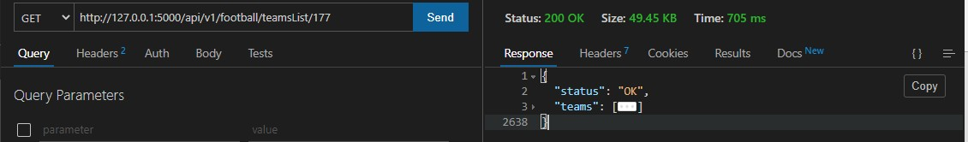

#### Test Case: BackEnd02

Test case description: Get News Data Pre-condition: Server is running.

**Total 1.9.2 News Data**

|  |  |
| --- | --- |
| **API** | https://newsapi.org |
| **Method** | GET |
| **Input Data** | **--** |
| **Expected Result** | The API should return the success status and the JSON of news data. |
| **Actual Result** | As expected |
| **Result** | Pass |

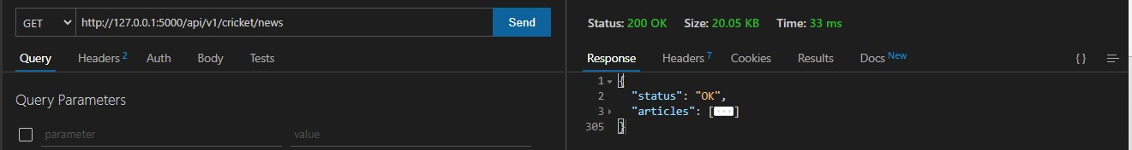

#### Test Case: BackEnd03

Test case description: Get Player Data Pre-condition: Server is running.

**Total 1.9.3 Player Data**

|  |  |
| --- | --- |
| **API** | https://apiv2.allsportsapi.com/football/?met=Players |
| **Method** | GET |
| **Input Data** | -- |
| **Expected Result** | The API should return the success status and the JSON of player data. |
| **Actual Result** | As expected |
| **Result** | Pass |

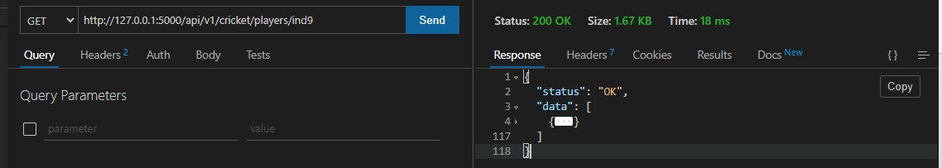

#### Test Case: BackEnd04

Test case description: Get Series Data Pre-condition: Server is running.

**Total 1.9.4 Series Data**

|  |  |
| --- | --- |
| **API** | https://api.cricapi.com/v1/series |
| **Method** | GET |
| **Input Data** | **--** |
| **Expected Result** | The API should return the success status and the JSON of Series data. |
| **Actual Result** | As expected |
| **Result** | Pass |

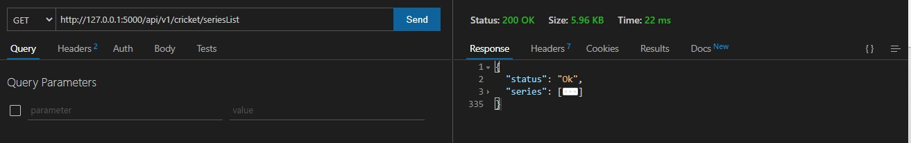

#### Test Case: BackEnd05

Test case description: Get League Data Pre-condition: Server is running.

**Total 1.9.5 League Data**

|  |  |
| --- | --- |
| **API** | https://apiv2.allsportsapi.com/football/?met=Leagues |
| **Method** | GET |
| **Input Data** | **--** |
| **Expected Result** | The API should return the success status and the JSON of League data. |
| **Actual Result** | As expected |
| **Result** | Pass |

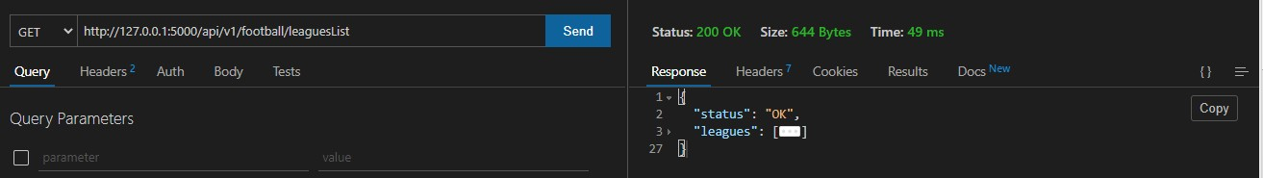

#### Test Case: BackEnd06

Test case description: Get Match Data Pre-condition: Server is running.

**Total 1.9.6 Match Data**

|  |  |
| --- | --- |
| **API** | https://apiv2.allsportsapi.com |
| **Method** | GET |
| **Input Data** | **--** |
| **Expected Result** | The API should return the success status and the JSON of Match data. |
| **Actual Result** | As expected |
| **Result** | Pass |

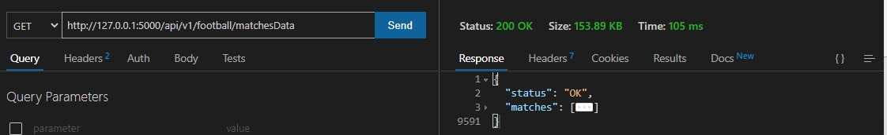

# Implementation

### Output screens

#### Football Output Screen

##### Home Page

This is the first page which user will encounter when they’ll visit our website.

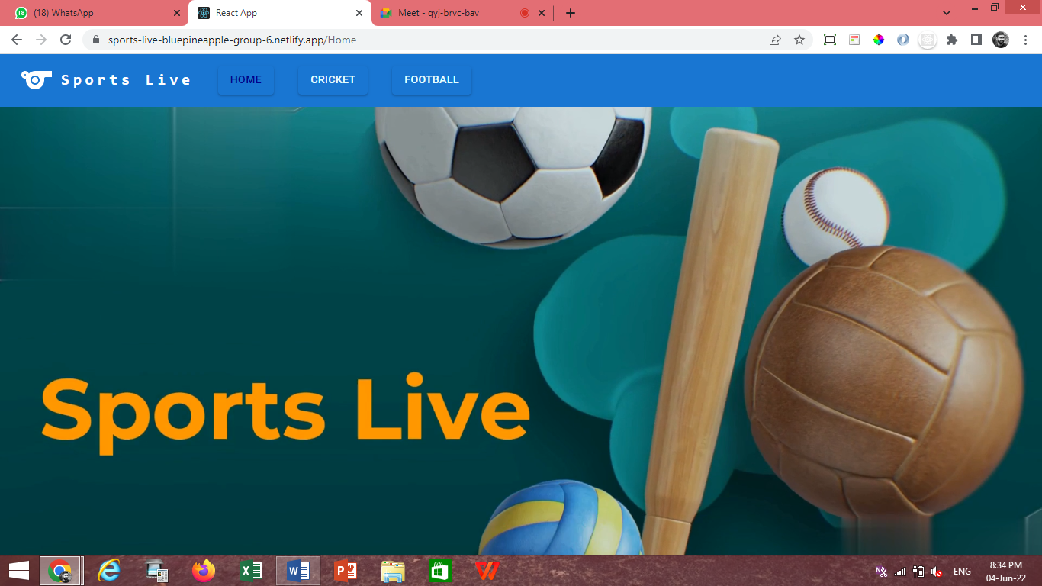

##### Football Home Page

When user will click on football on the main navigation page they’ll land on football Home page showing Featured matches and some important news.

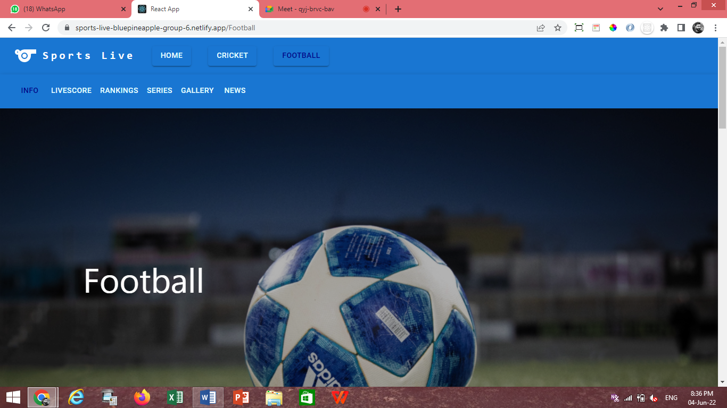

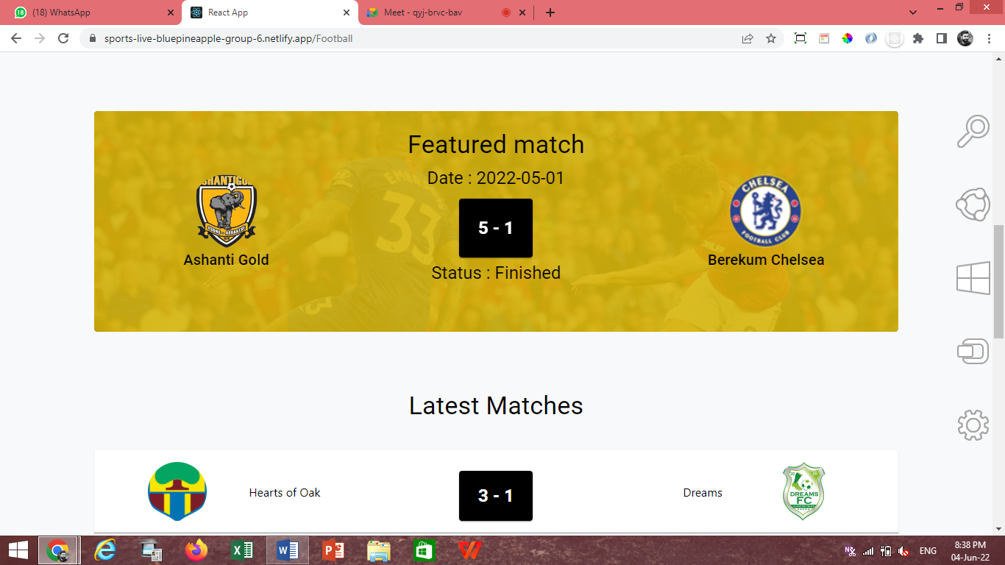

##### Football/Live Scores

This page shows all the live scores of matches happening around the world.

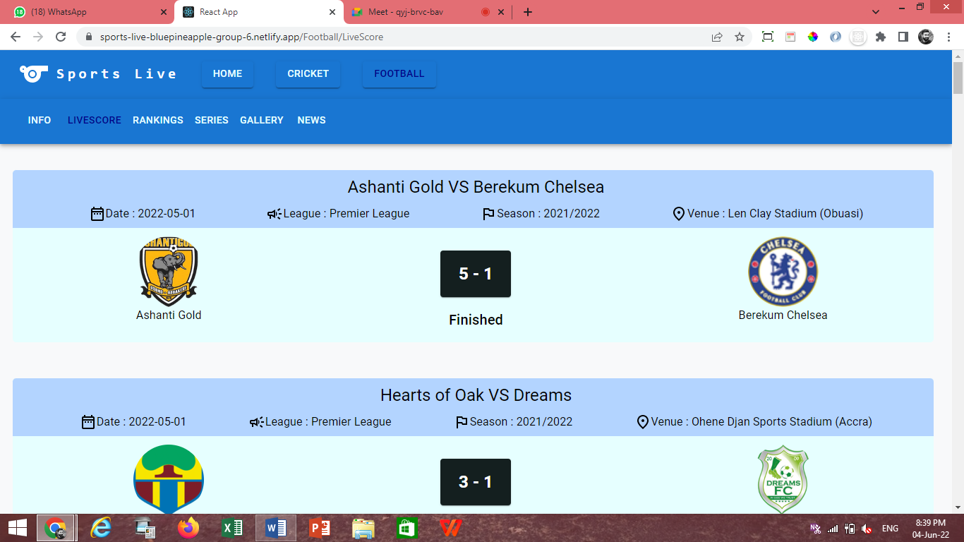

##### Football/Rankings

This page shows FIFA Rankings of Teams.

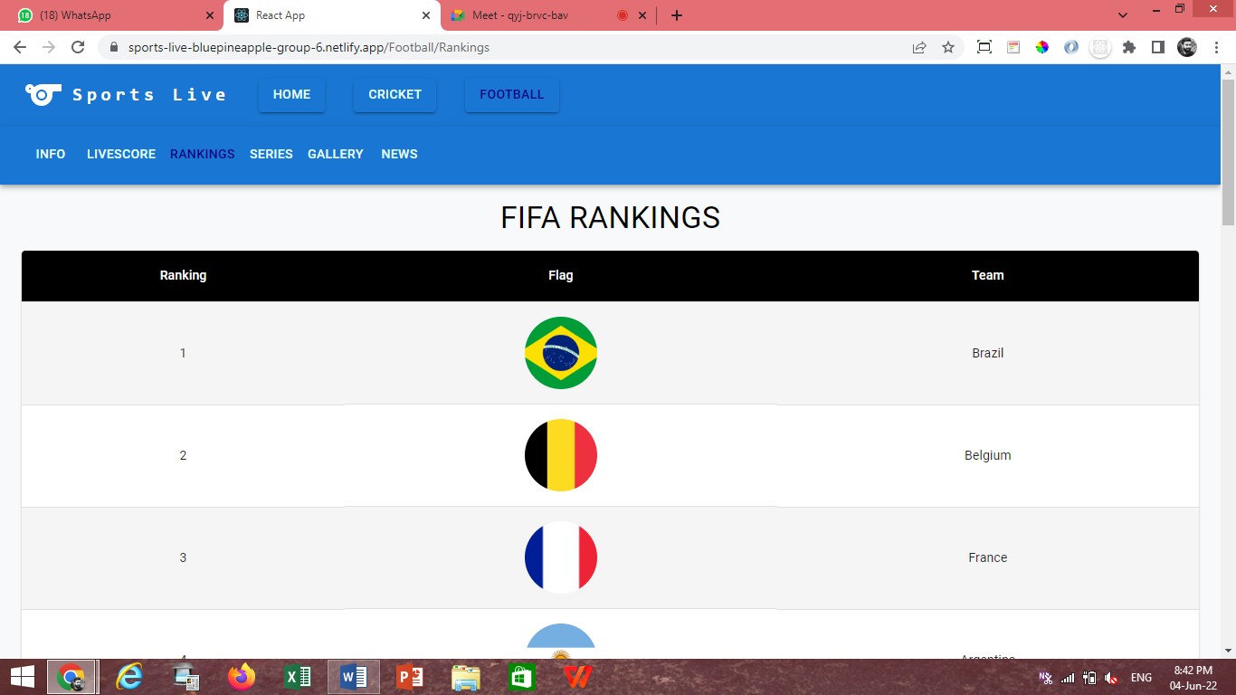

##### Football/Series

##### This page shows List of All the Top Leagues Information.

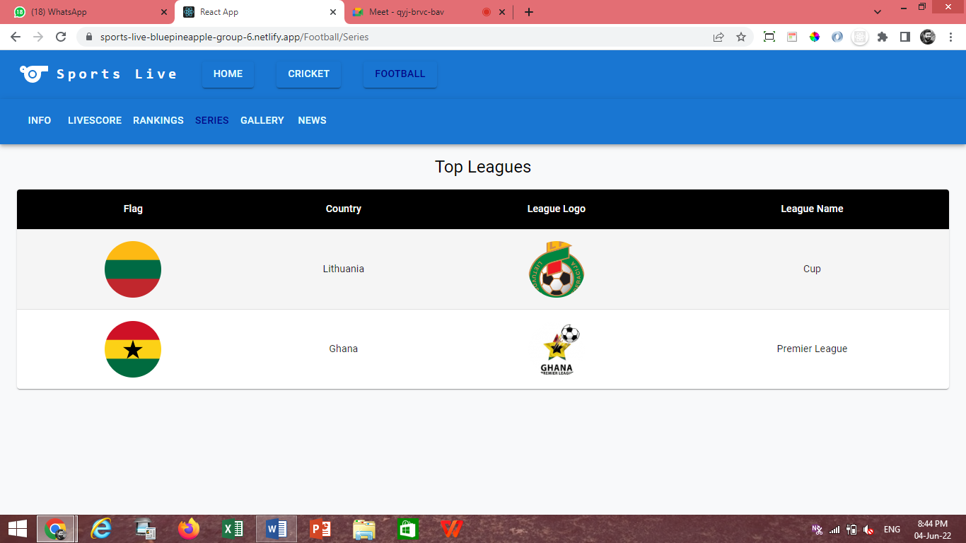

##### Football/League/League Info/Schedule

This page shows all the Schedule Matches of particular League.

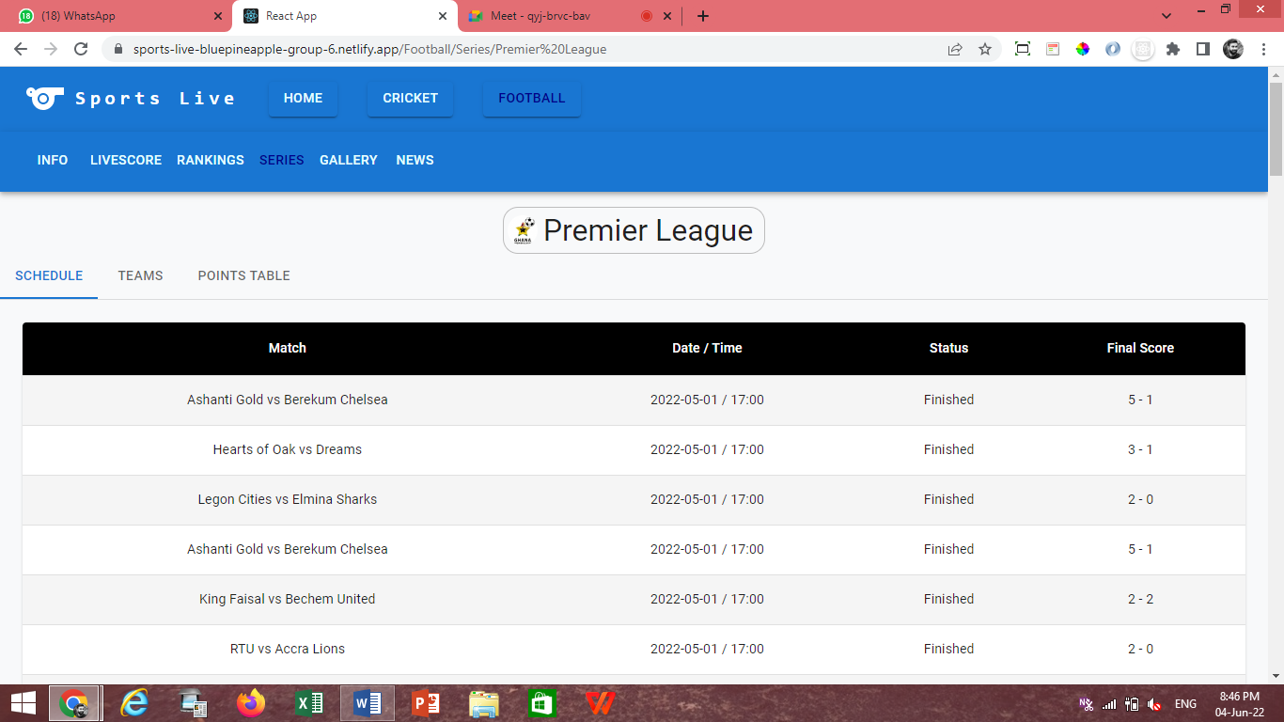

##### Football/League/League Info/Teams

This page shows all the Teams which play under Particular League.

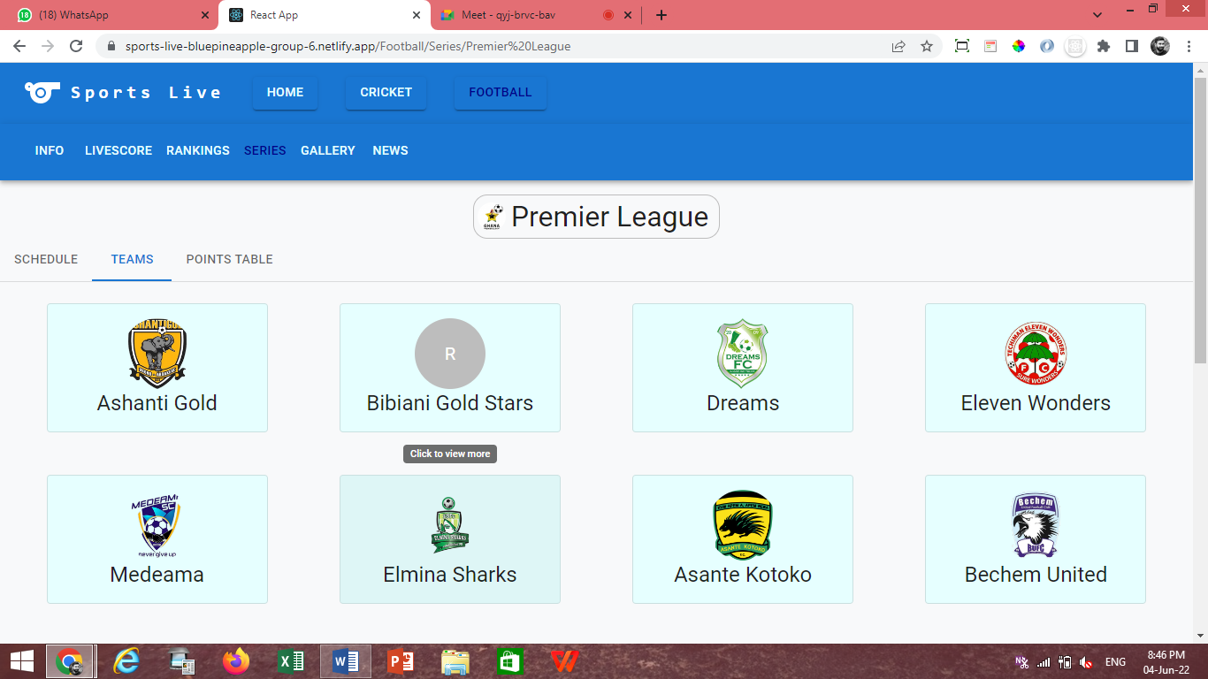

##### Football/League/League Info/Points Table

This page shows Point Table of Particular League.

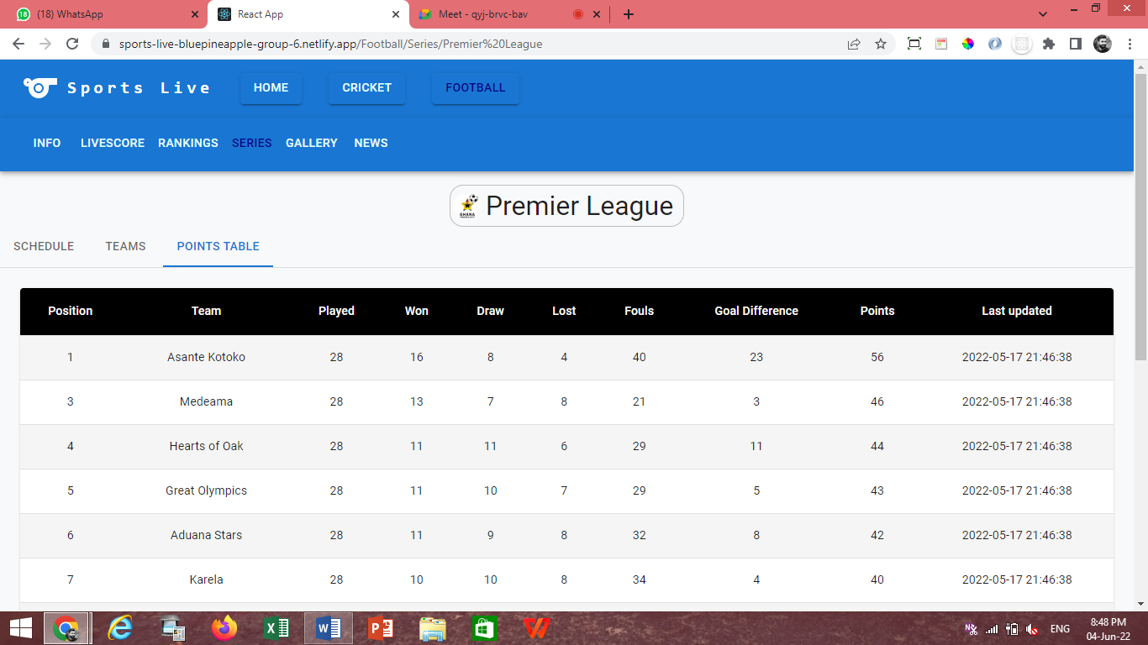

##### Football/Team Info

This page shows all the Team of Info Particular Team.

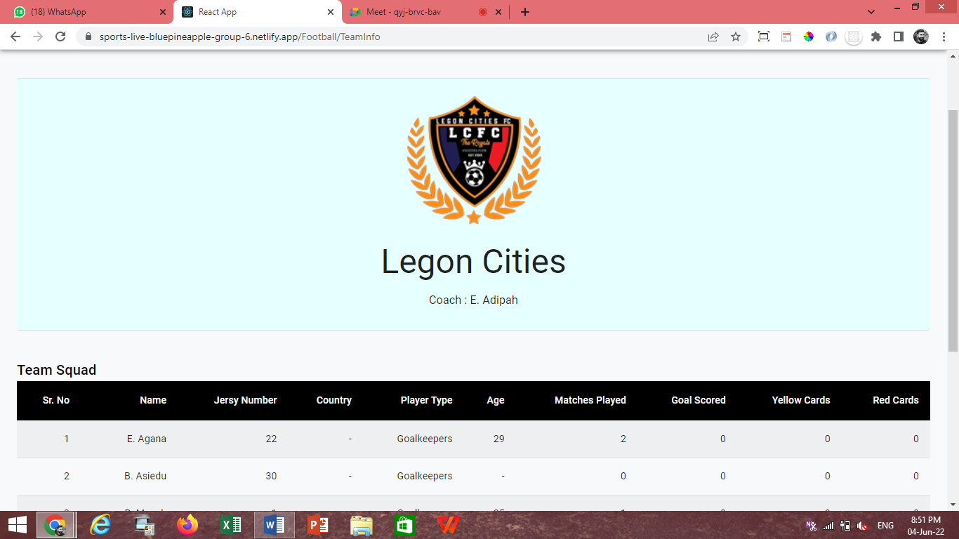

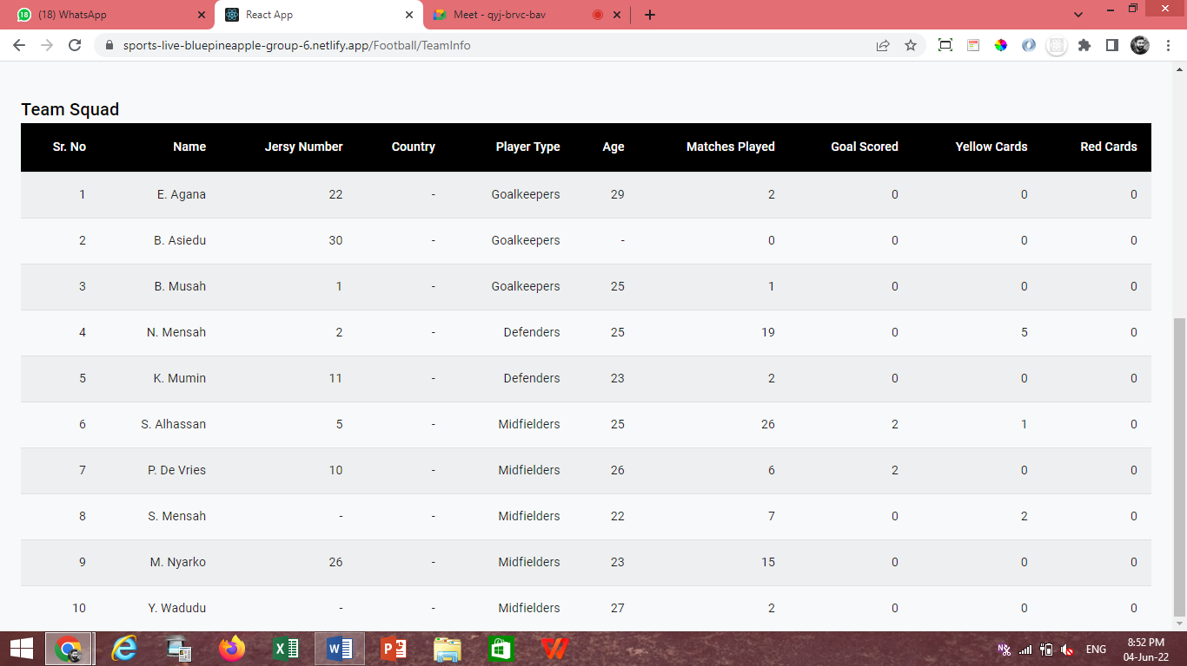

##### Football/Gallery

This page shows all the Images of Football with some description.

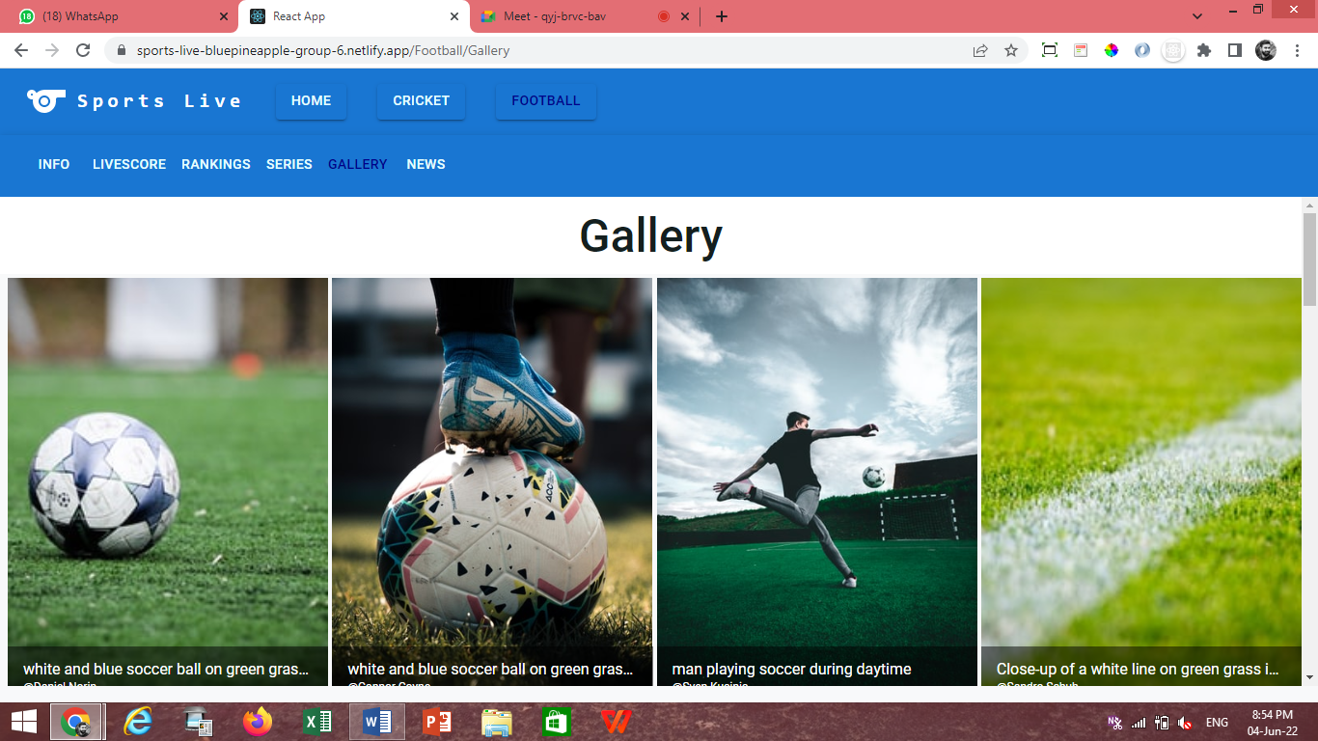

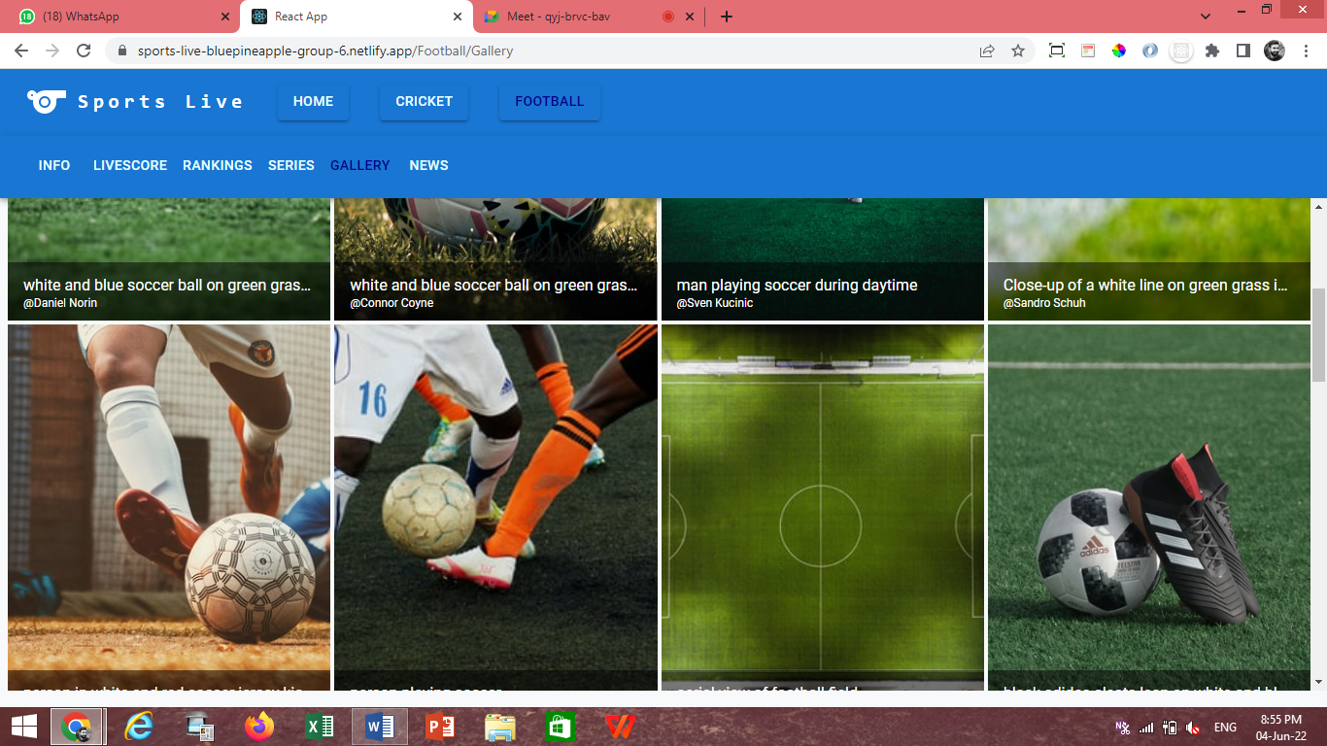

##### Football/News

This page shows all the Latest News of Football.

##### 

##### 

#### Cricket Output Screen

##### Cricket

When user will click on Cricket on the main navigation page they’ll land on Cricket Home page showing Featured matches and some important news.

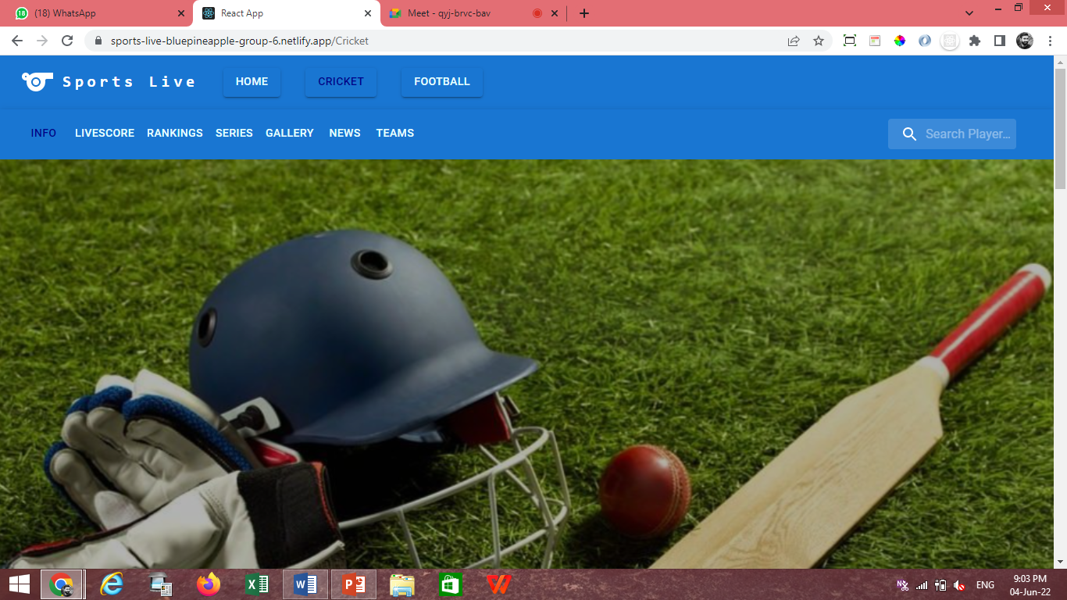

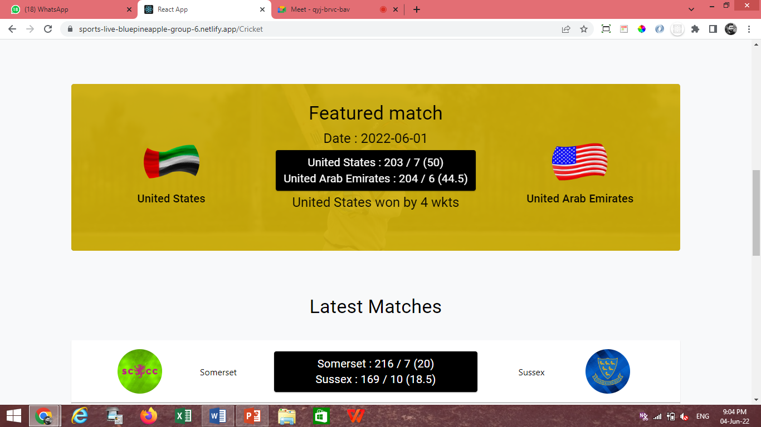

##### Cricket/Live score

This page shows all the live scores of matches happening around the world.

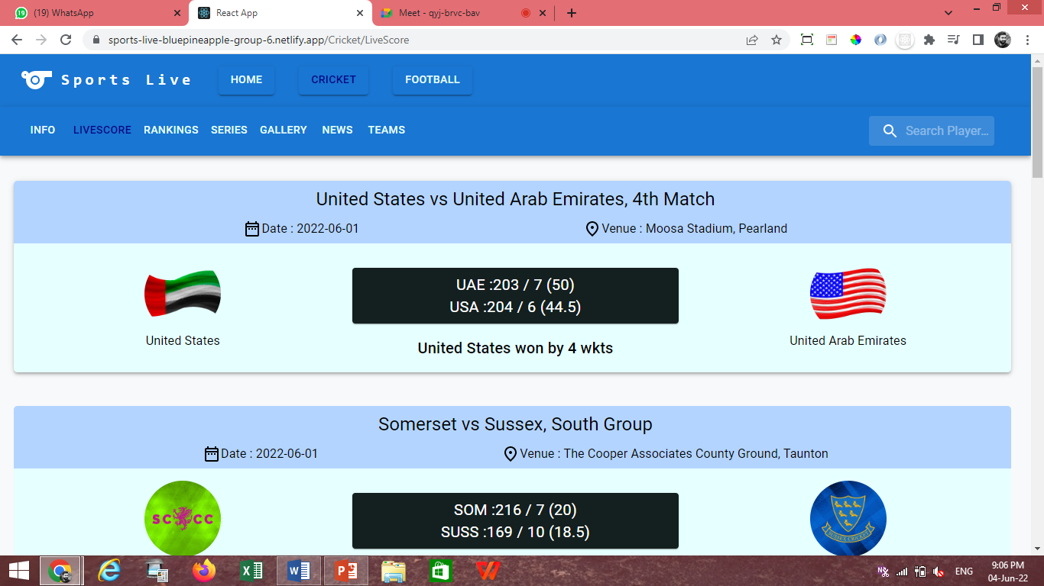

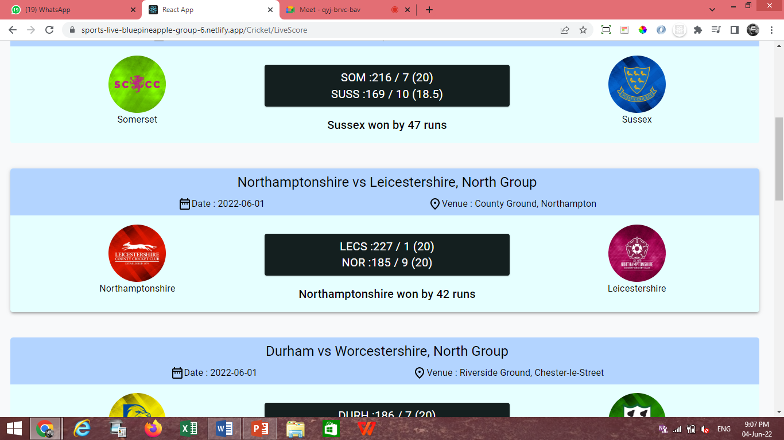

##### Cricket/Rankings/Batting/Test

This page shows Ranking of players based on their Role and Match format.

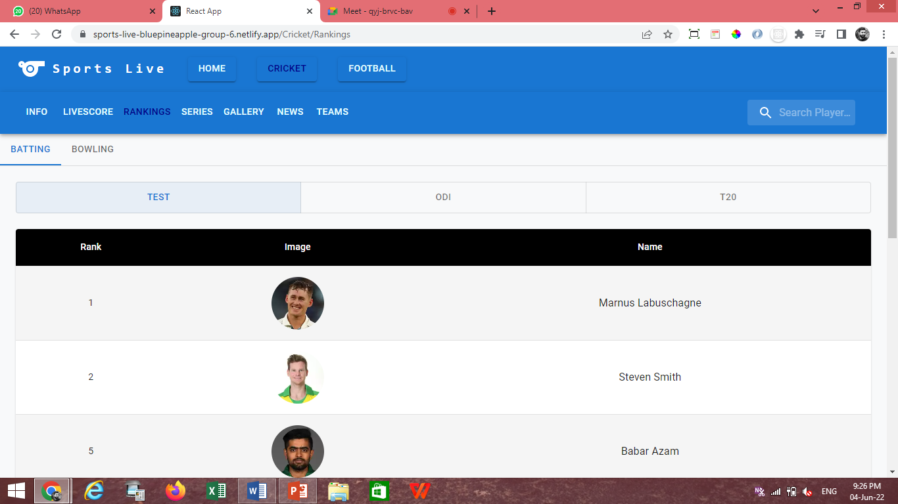

##### Cricket/Ranking/Bowling/Test

This page shows Ranking of players based on their Role and Match format.

##### 

##### Cricket/Series

This page shows List of Series.

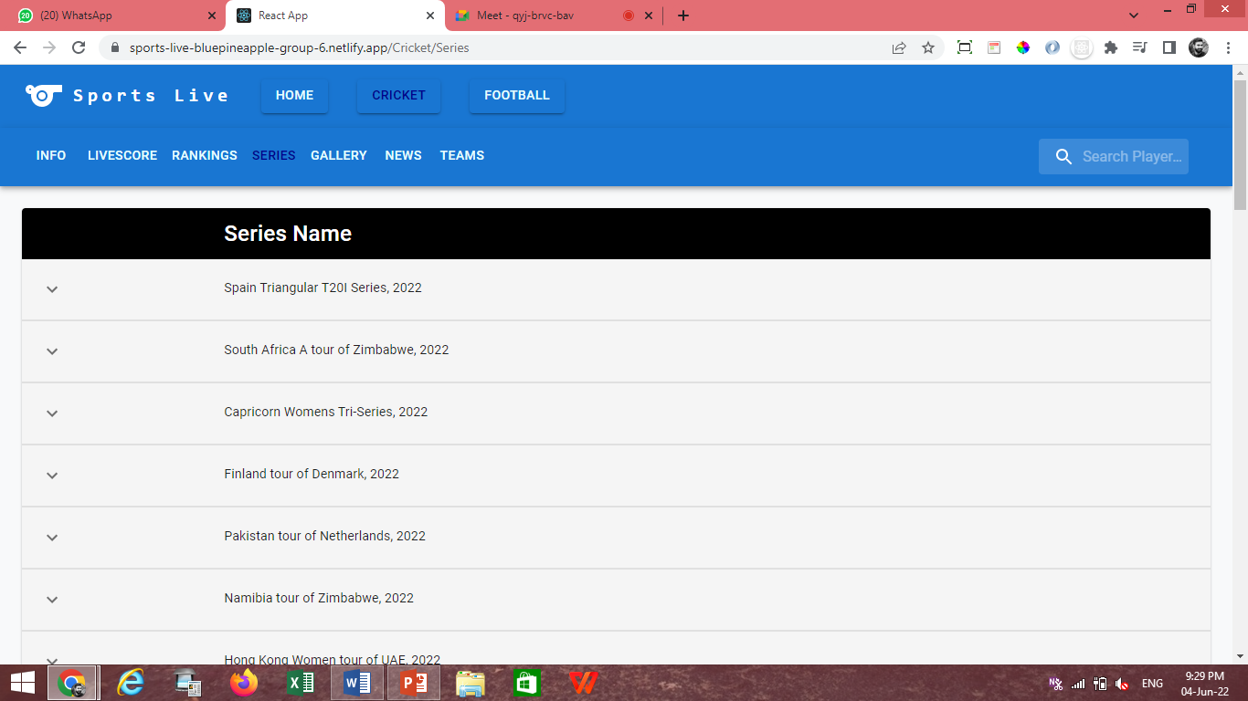

##### Cricket/Gallery

This page shows Images of cricket with some description.

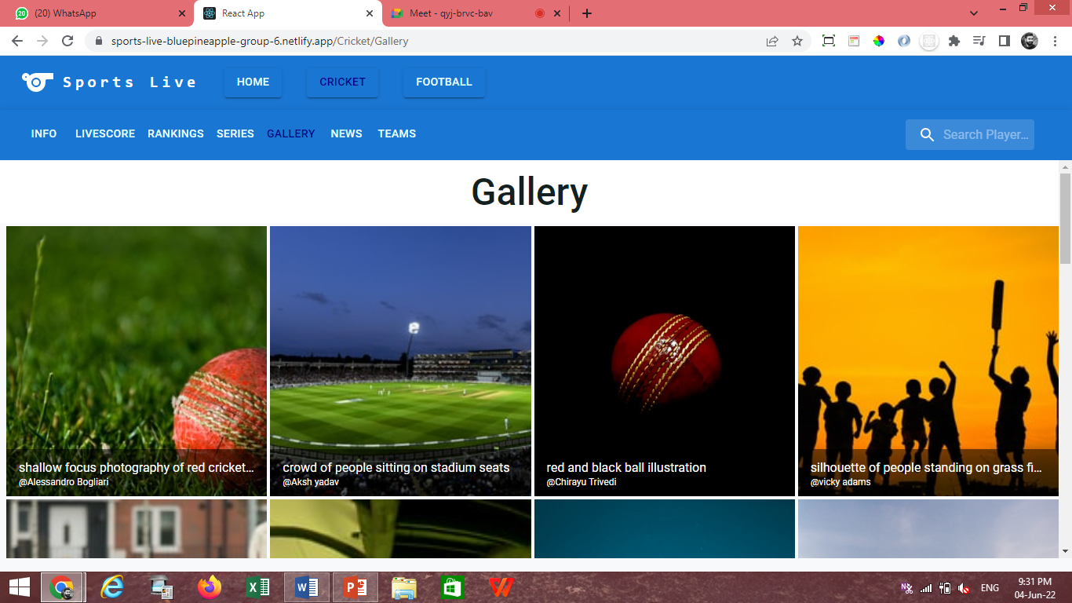

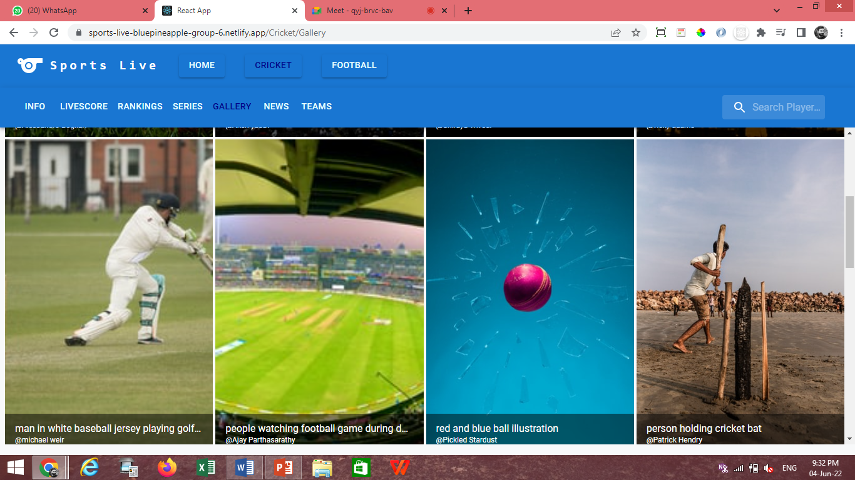

##### Cricket/News

This page shows All Latest News of Cricket.

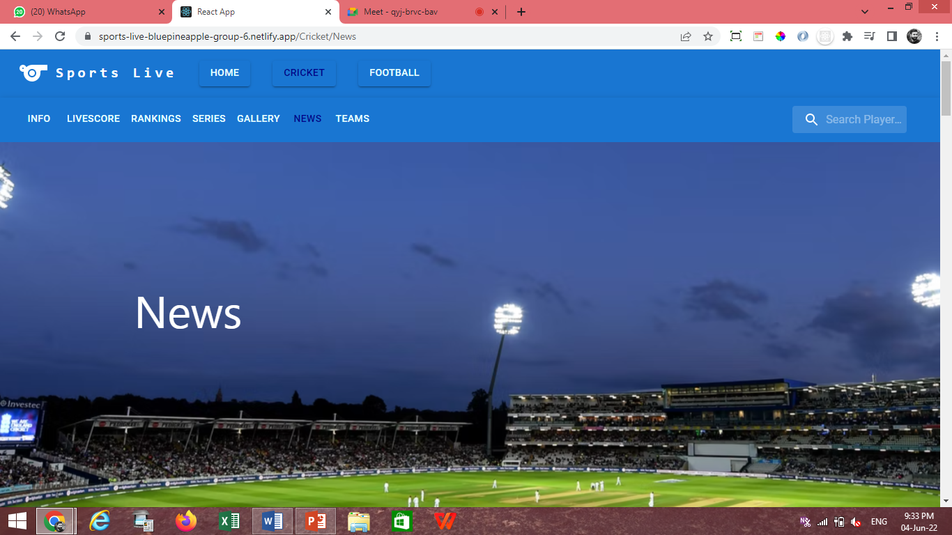

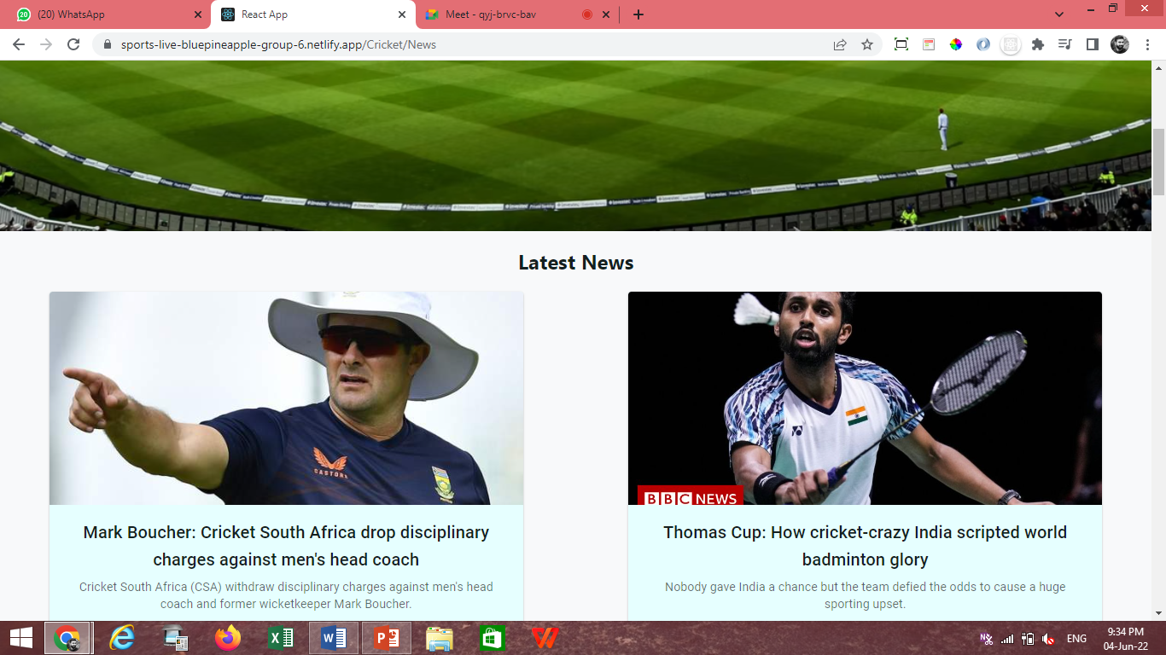

##### Cricket/Teams

This page shows all the Teams.

##### 

##### 

##### Cricket/Team/Schedule

This page shows all the Schedule Matches of Particular Team.

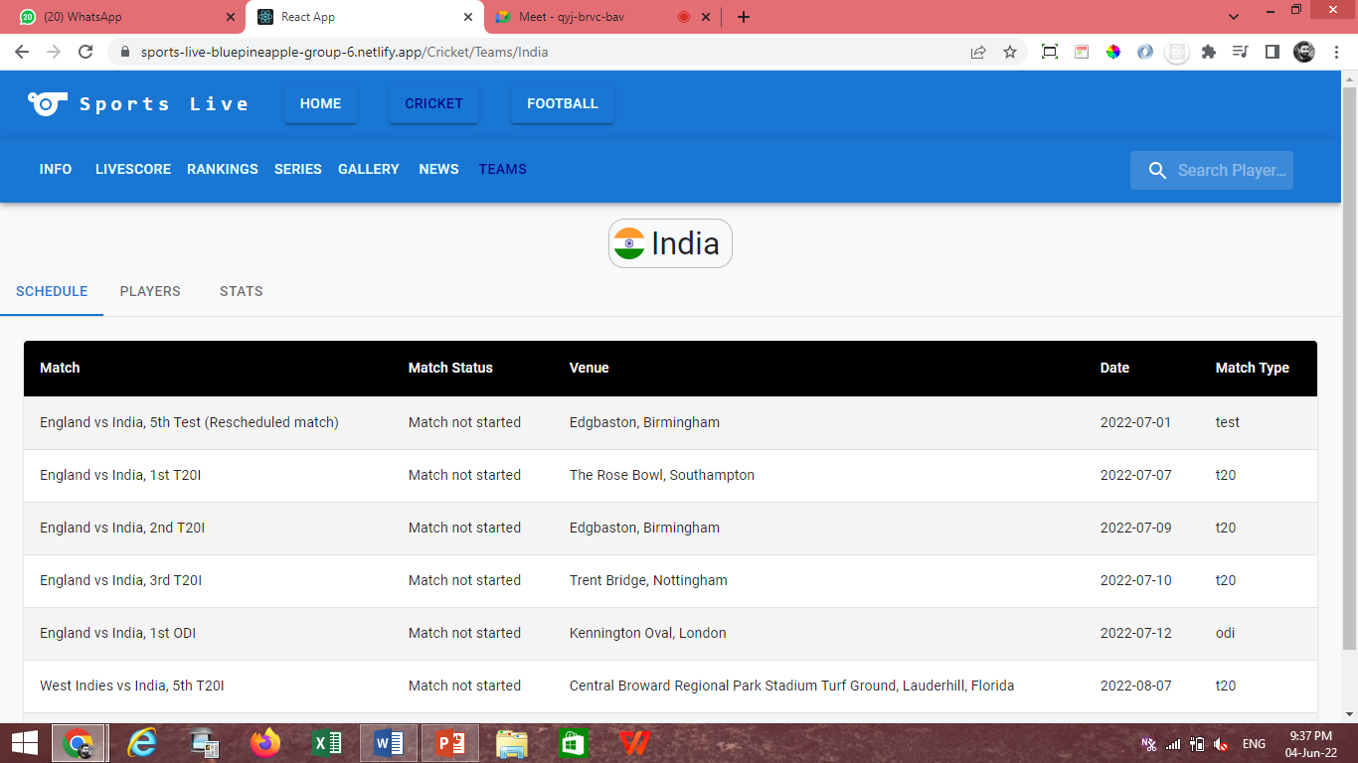

##### Cricket/Teams/Players

This page shows all the Players which play under particular Team.

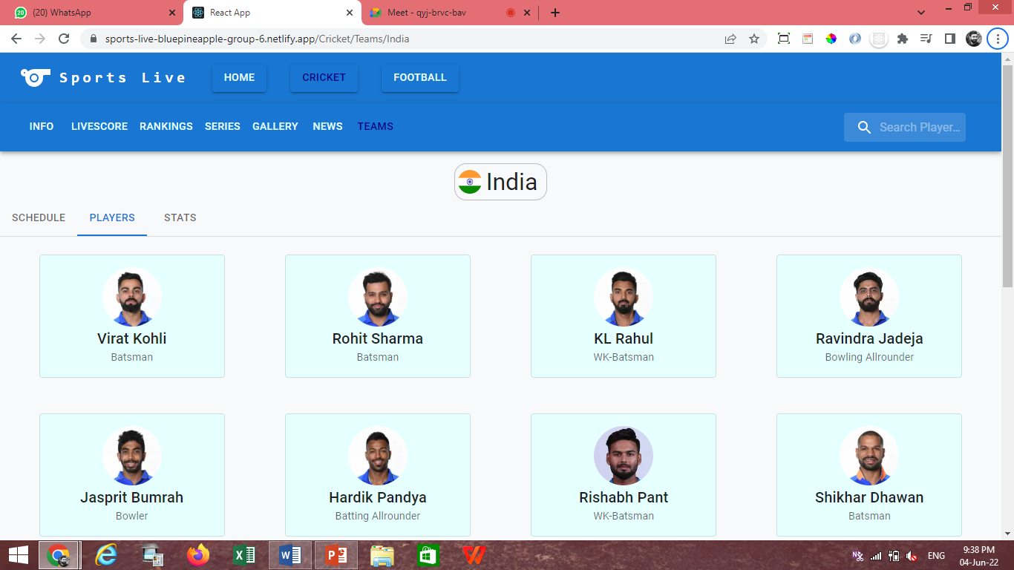

* **Cricket/Teams/Stats**

This page shows the Statistic of Particular Team.

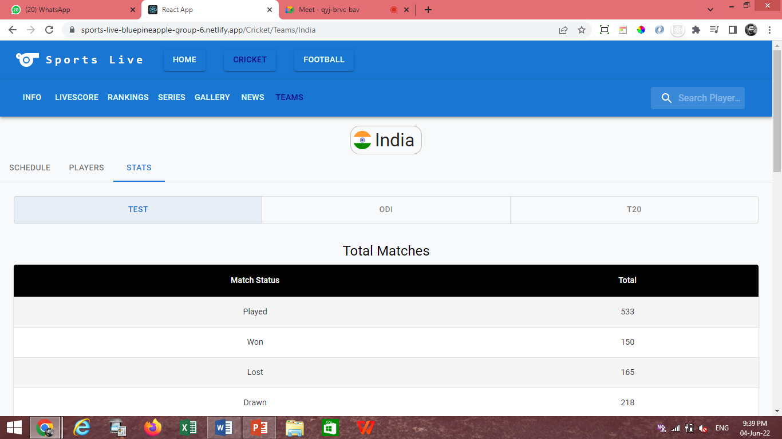

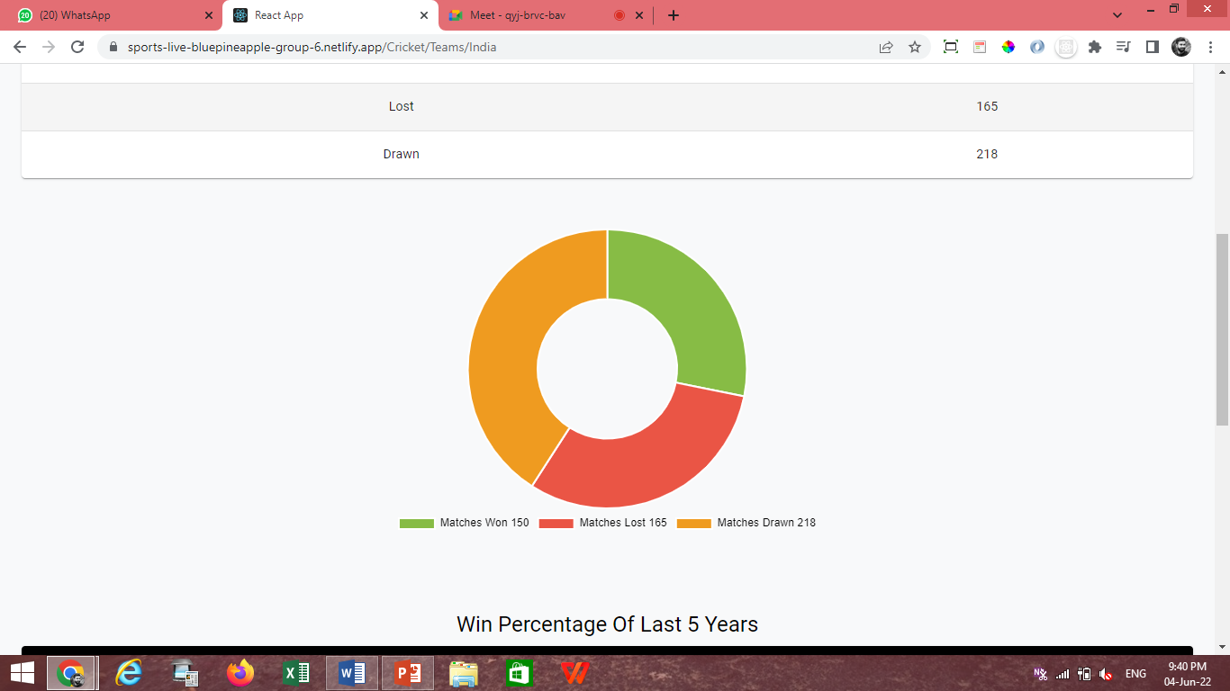

Search

##### Cricket/Player Search

On This page we can search player by player name.

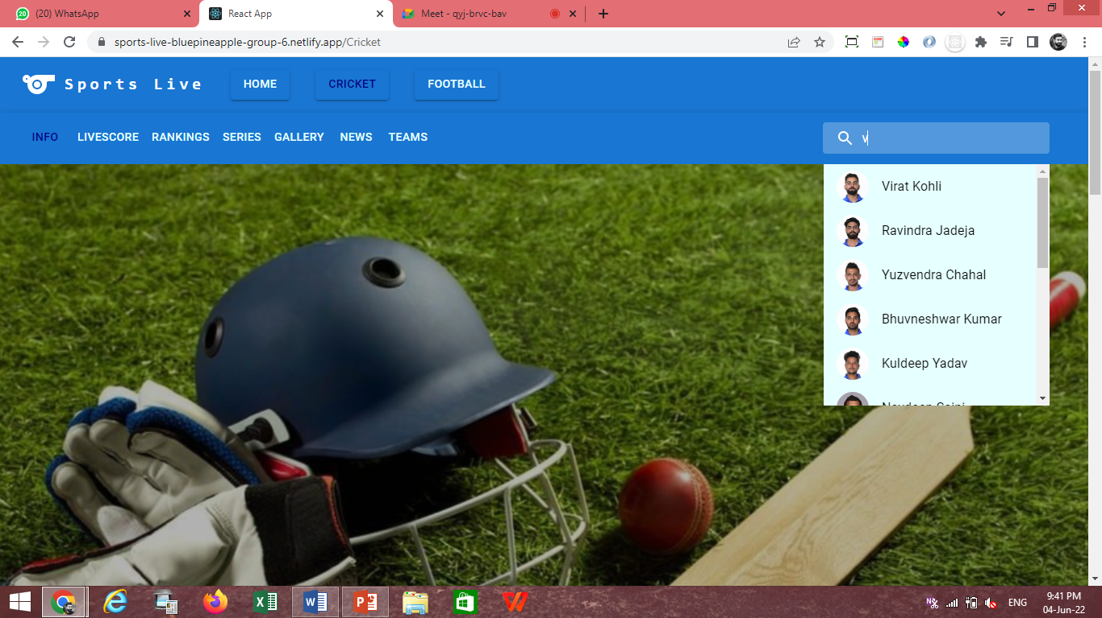

##### Cricket/Player Info

This page shows Detailed player Information.

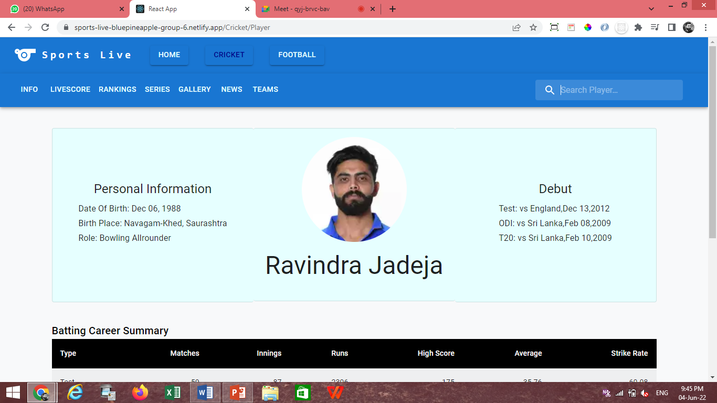

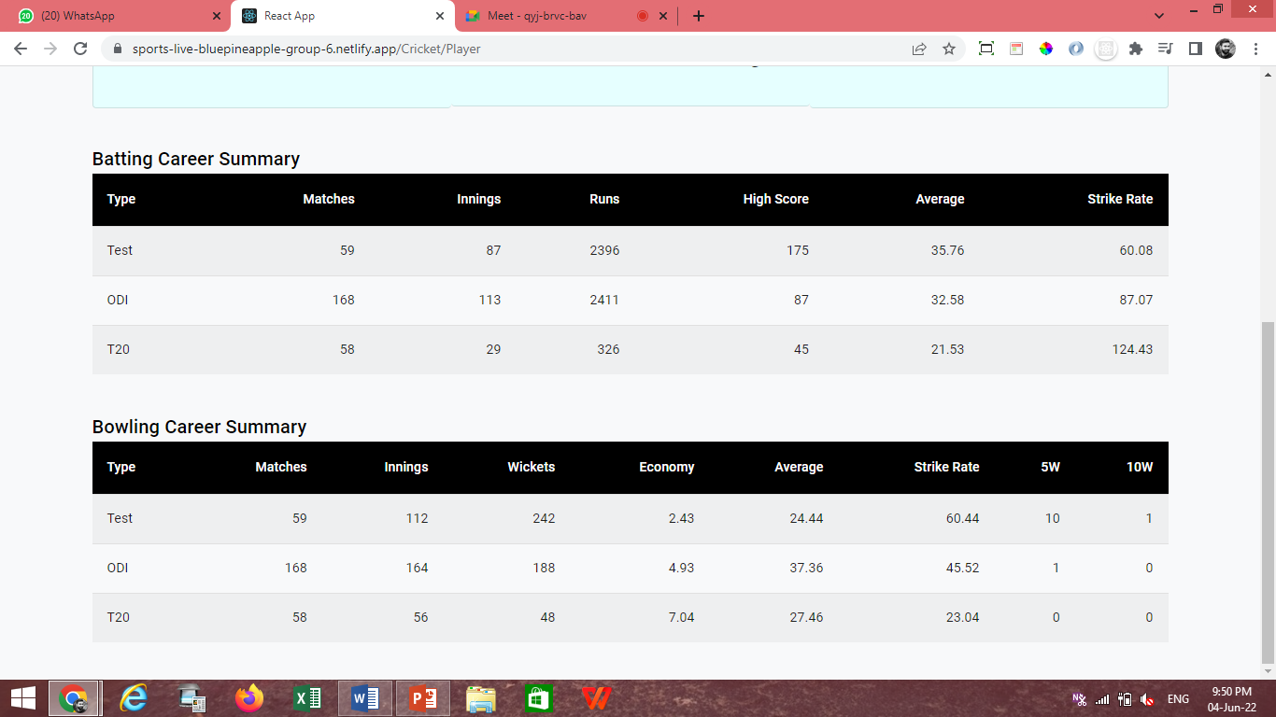

### DRAWBACKS & LIMITATIONS

It gives information about what the defined system is unable to do at its present state which occurs through variations in collected data. They are listed as follows,

* This project is developed for web application; hence it is not completely responsive to mobile application.
* Users can only view website in English language.
* This website is not showing complete data for the available sports as the API’s used are limited ones.

### FUTURE ENHANCEMENT

It contains the decision-making artifact that helps estimate, refine, and prioritize everything that might sometime in the future be implemented. Here is a list of few enhancements,

* User will be able to see more sports on this website.
* User can do Online Ticket Booking of matches.
* User can do Online Shopping of sport related equipment’s on this website.

### OTHER TRAINING ACTIVITIES

#### Learning Sessions

* JavaScript Basics
* Advanced JavaScript
* HTML & CSS basics
* Mobile First Or Responsive layout Using HTML5 & CSS3
* Reacts
* Exception Handling
* Database Management System
* Programming Skills
* Project Estimation
* Project Planning

#### Tasks & Assignments

* 5 Programs Using C
* 3 Programs Using Python
* 6 Programs Using JavaScript
* 5 Pages Design using HTML, CSS

# CONCLUSION

This internship was a professional experience in the world of computer science. In a nutshell, it was an excellent and rewarding experience. All weekly as well as monthly tasks offered opportunities to learn and develop knowledge and skills in many areas and helped in gaining a lot of experience in web, database, and cross platform development notably by learning a new and innovative knowledge in react js and node js web development.

Finally, this internship allowed autonomously, acquiring skills in design and architecture application which helped in exploring more in the technology world.

# References

* [What is website theme?](https://www.freecodecamp.org/news/website-theming-with-css-custom-properties-and-gatsbyjs/)
* [Javscript.info](https://javascript.info)
* [React mui](https://mui.com)
* [ReactJS](https://reactjs.org/docs/getting-started.html)
* [Bree](https://www.npmjs.com/package/bree) scheduler
* [Mongoose](https://mongoosejs.com/docs)

# Glossary

This is an alphabetical list of words relating to a specific subject, text, or dialect, with explanations, a brief dictionary.

| Term | Meaning |
| --- | --- |
| API | Stands for Application Programming Interface. It is a set of functions and procedures that allow for the creation of applications that access data and features of other applications, services, or operating systems. |
| Caveat | A warning or proviso of specific stipulations, conditions, or limitations. |
| Development Lifecycle | A framework defining tasks performed at each step in the software development process. |
| Effort Estimation Report | A comparison of estimated time for tasks vs actual time taken to complete them. |
| Express JS | It is a back-end web application framework for Node.js, released as free and open-source software under the MIT License. It is designed for building web applications and APIs. |
| Feasibility study | Assessment of practicality of proposed project or plan. |
| Gantt chart | A graphical description of a project schedule. |

|  |  |
| --- | --- |
| Term | Meaning |
| Git | Software for tracking changes in any set of files, usually used for coordinating work among programmers collaboratively developing source. |
| GitHub | A provider of Internet hosting for software development and version control using git. |
| JSX | It is a syntax extension to JavaScript recommended using with React to describe what the UI should look like. |
| Libraries | A collection of non-volatile resources used by computer programs, often for software development. |
| Node JS | It is an open-source, cross-platform, back-end JavaScript runtime environment that runs on the V8 engine and executes JavaScript code outside a web browser. |
| Persona | An example of the kind of person who would interact with a system. |
| React JS | JavaScript library for building user interfaces. |
| Requirement | Description of what a system should do. |
| Stand-up Meeting | Short, time-boxed team status check, typically at the start of the day. |
| Technical Feasibility | The process of proving that the concept is technically possible. |
| Test Case | A set of actions executed to verify a particular feature or functionality of an application. |
| UI Testing | A type of software testing where individual units or components in the frontend of software are tested. |
| User story | A description of a software feature from an end-user perspective. |
| Version control | The practice of tracking and managing changes to software code |